Tutorial 0. Setting up the work environment.

* 1. Create a Google Account.

For this module, we are going to be using two parts of the vast Google suite of tools. The first thing that you must do is create an account. The University of the Highlands and Islands has given you a student number. For this particular instance, I will use a made-up student number (1122131) but you should use your student number.

Firstly, go to Google ([www.google.co.uk](http://www.google.co.uk)):

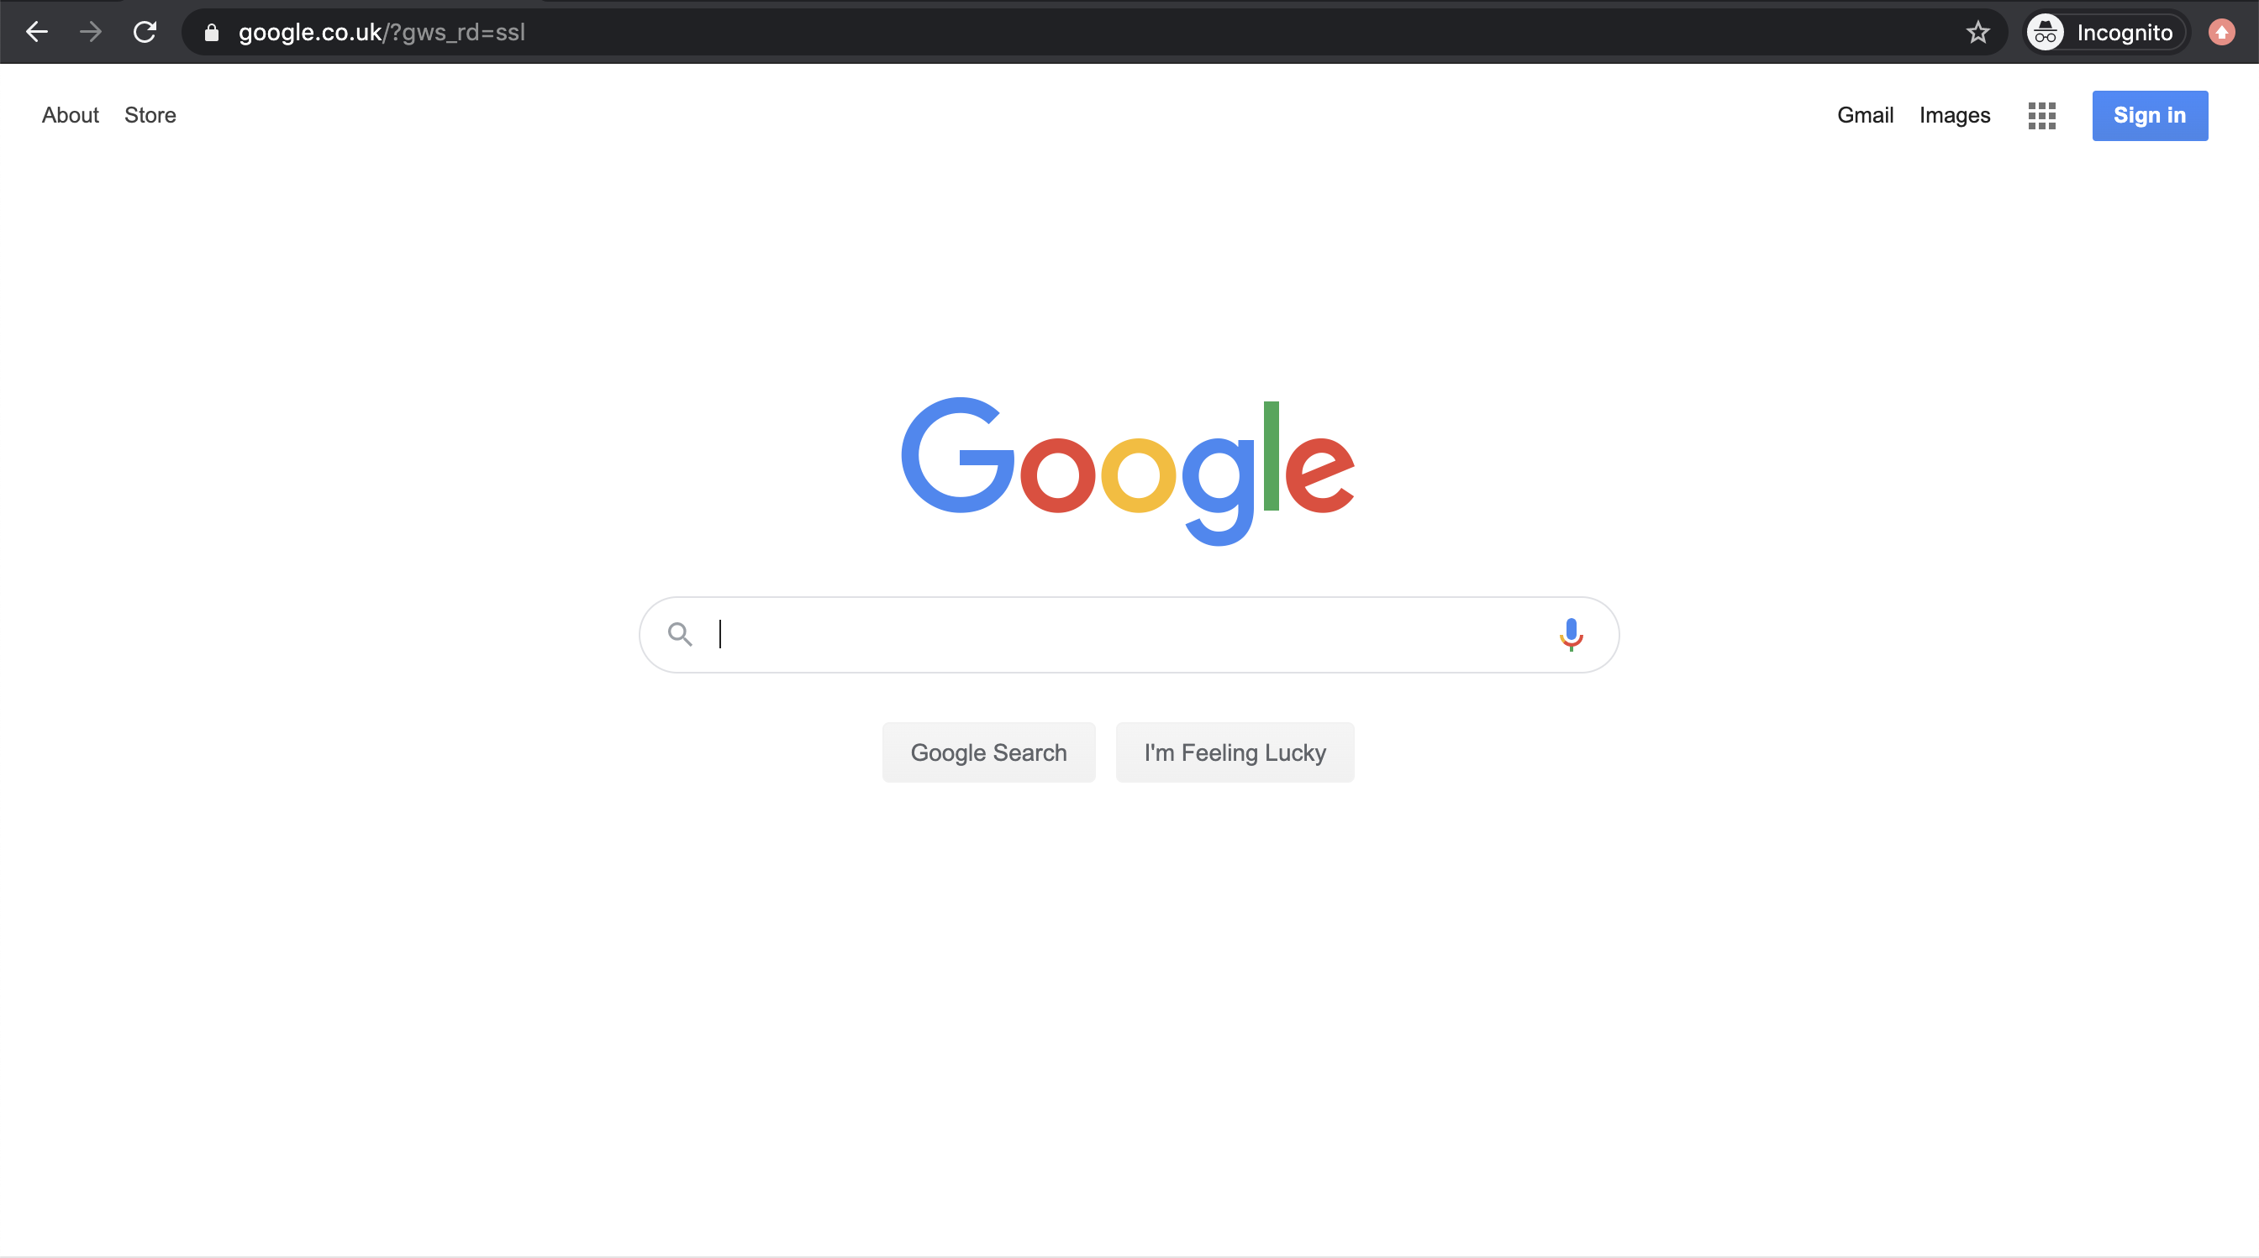

Click on the “Sign in” button in the top right-hand corner.

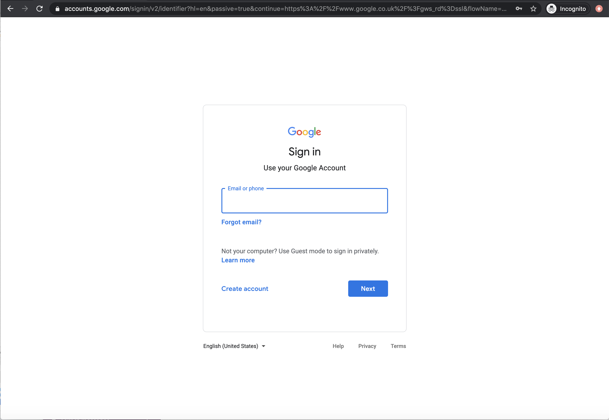

Now, click on Create account. It is on the left-hand side of the box in the centre of the window.

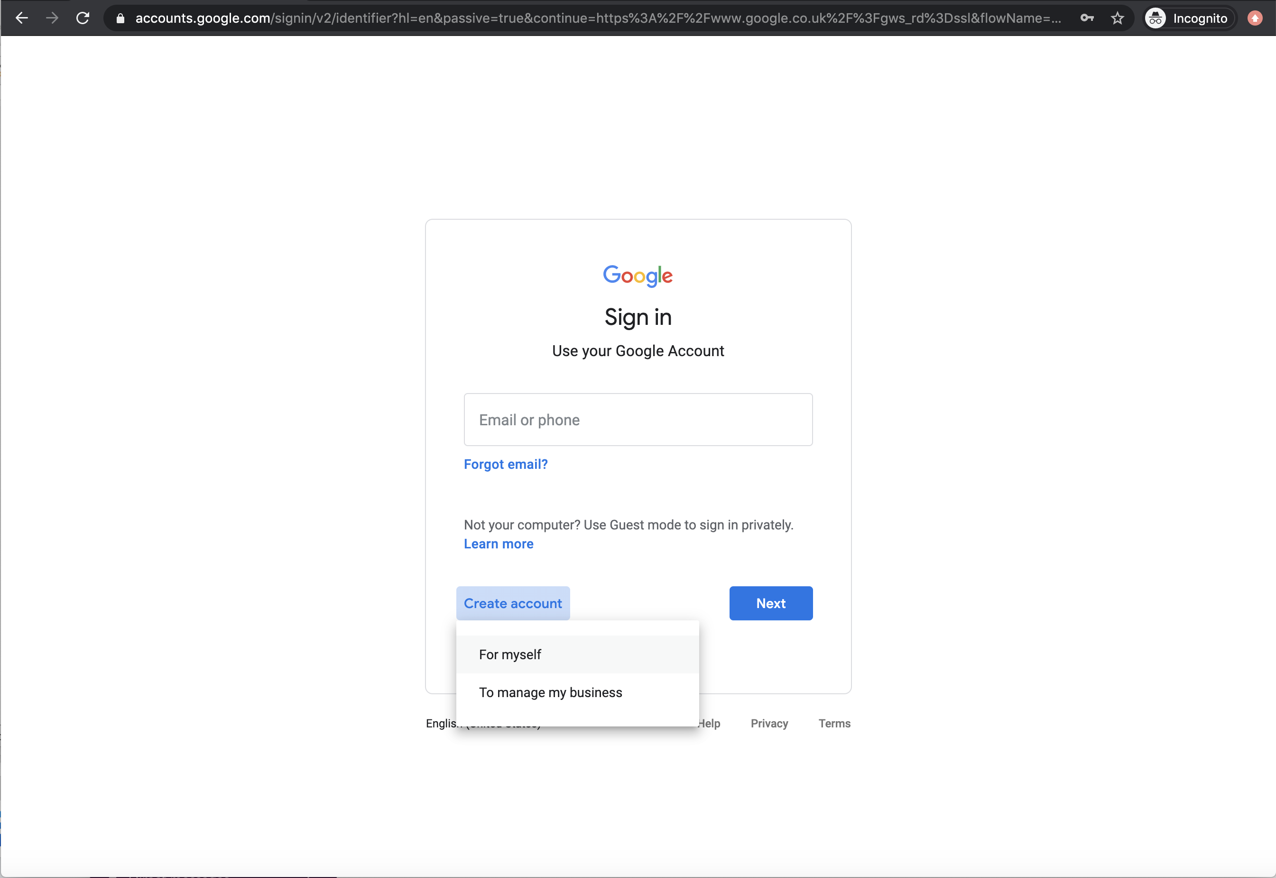

When prompted, click “For myself”.

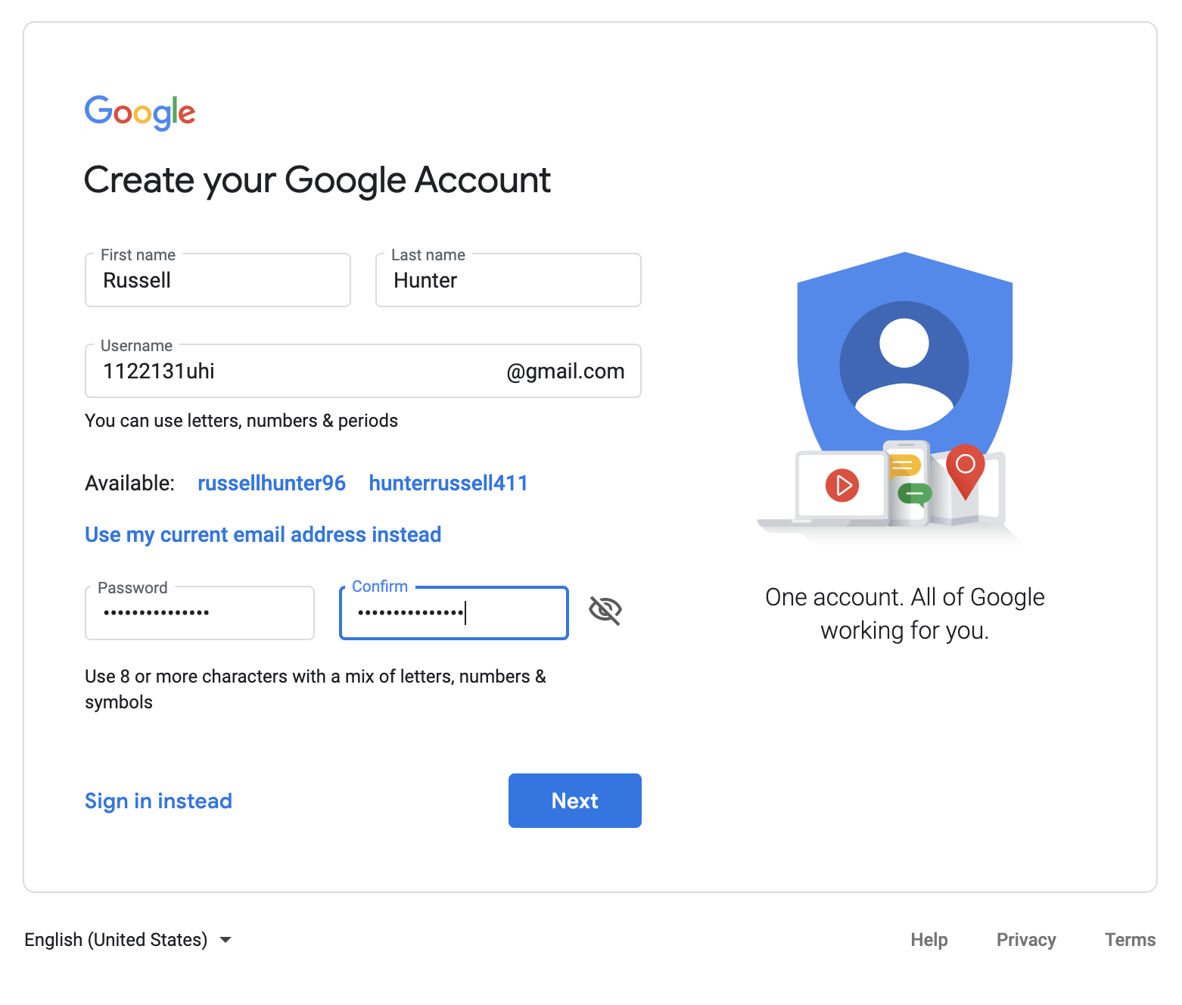

Fill in the details. For username, notice that I have used <student number>[uhi@gmail.com](mailto:uhi@gmail.com) i.e. [1122131uhi@gmail.com](mailto:1122131uhi@gmail.com)

Make up a secure password (keep a note) and click Next:

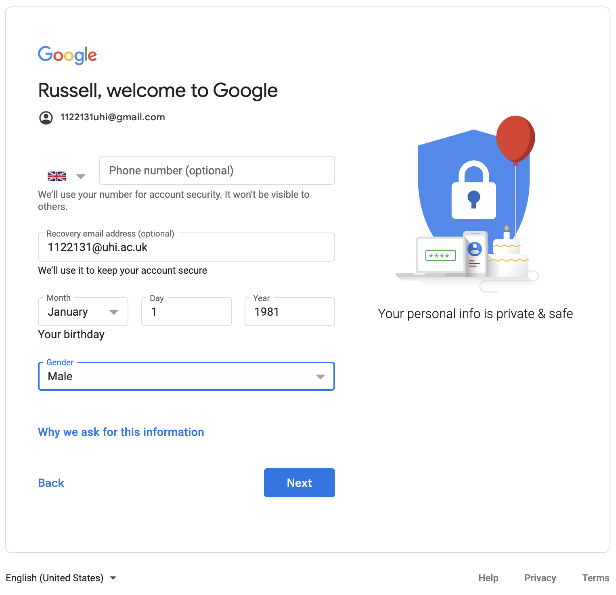

Add your details. You don’t need to put your phone number in, but I would suggest adding your uhi email address. In my case it is [1122131@uhi.ac.uk](mailto:1122131@uhi.ac.uk). Fill out your date of birth and the gender drop down and press next and finish off the signup process.

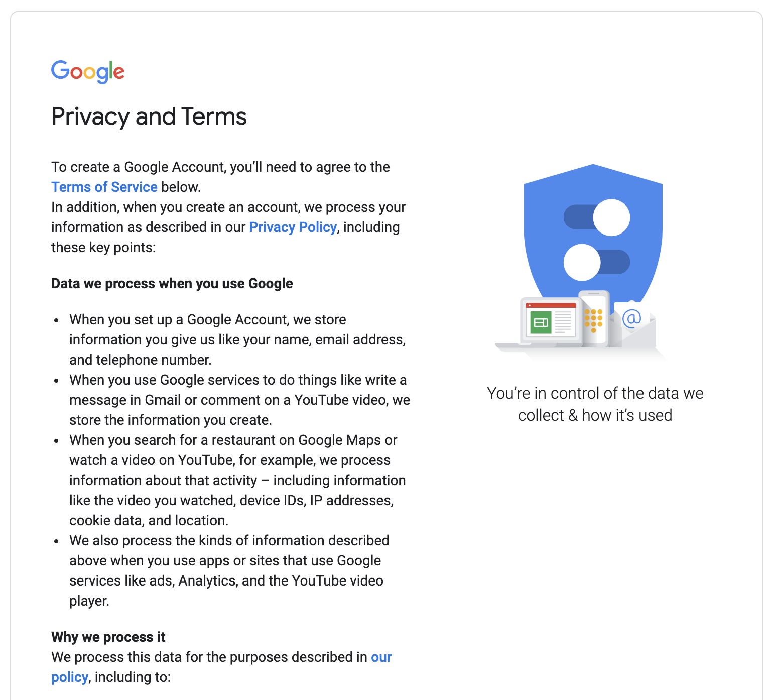

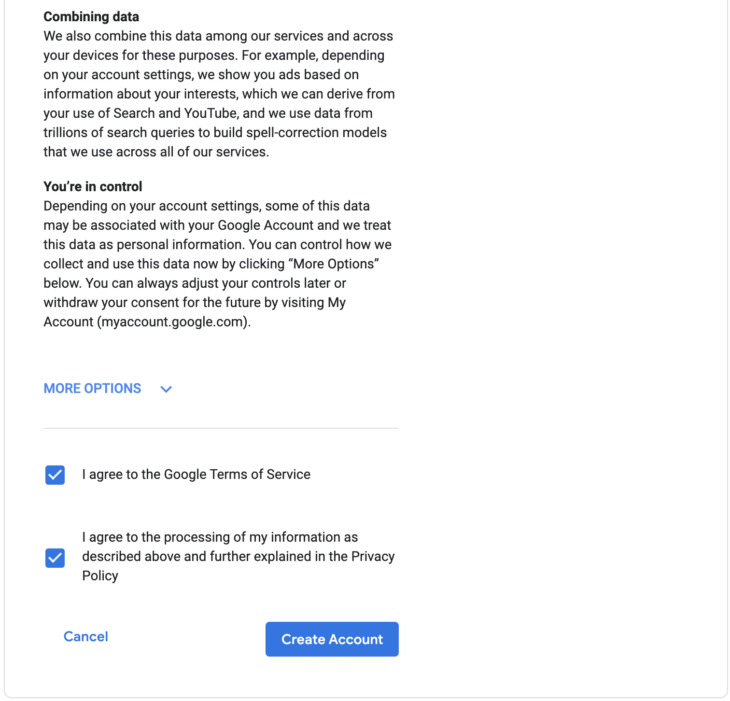

Click “Create Account”.

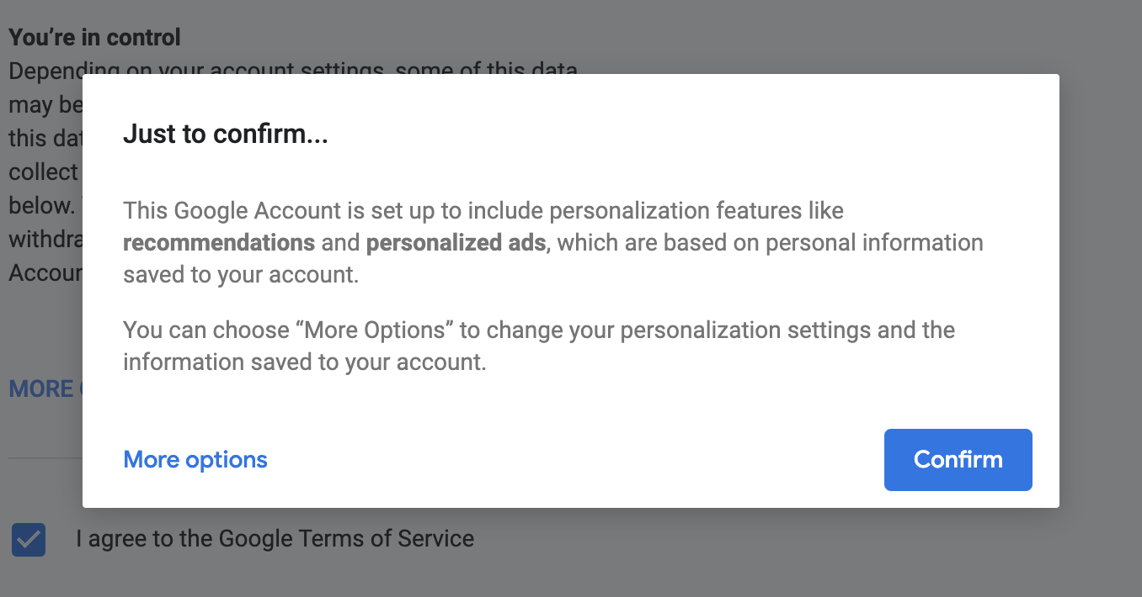

Click “Confirm”.

Congratulations you have created a Google account and you can see something like shown below in the browser in the top right corner:

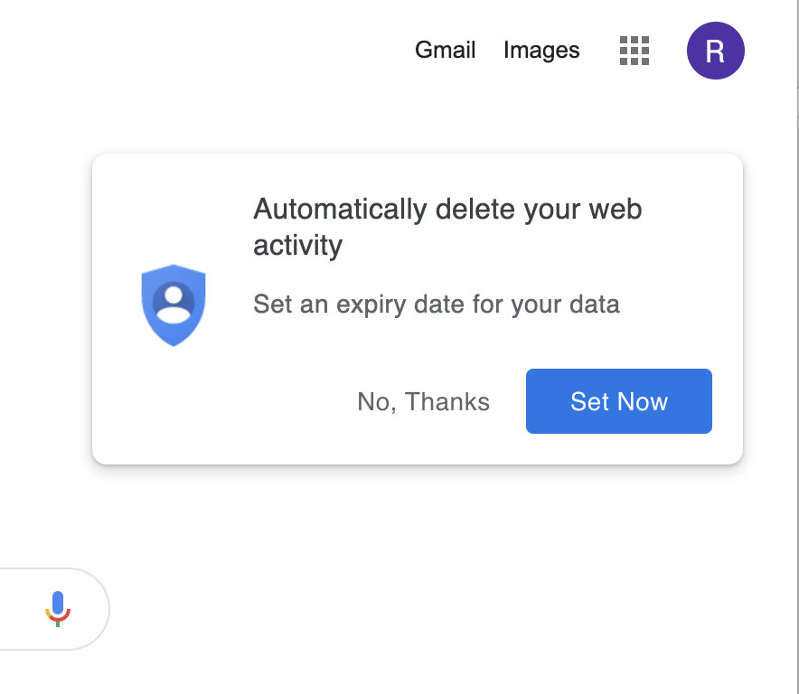

**Why are we asking you to do this?**

We will be using a number of Google services to allow you to work easily with big data, carry out statistical analysis using R and create machine learning models using Tensorflow all in one place. In previous years, students have had to use Virtual Machines, build local bespoke systems that require linux terminal experience, MySQL experience, python experience not to mention deal with laptops sometimes not having Virtualisation on and thus having to configure the system BIOS.

Now, that you have an account, the first thing you should do is send an email from this account with this template:

To: [Russell.Hunter.perth@uhi.ac.uk](mailto:Russell.Hunter.perth@uhi.ac.uk)

CC: 1122131@uhi.ac.uk

Subject: 0.1 - Google account created for 1122131

*The text body below should read:*

Hi Russell,

I have created the required google account with the address [1122131uhi@gmail.com](mailto:1122131uhi@gmail.com).

Thanks,

1122131

Things to notice above are, the email is sent to my real lecturer UHI account and I (as a pretend student with the student number 1122131) have CC’d my pretend student self in the email. Also, in the subject I have added 0.1, this lets me know which part you have completed in context to the tutorial.

To do this you will need to go into gmail. In the top right hand corner click on “Gmail”:

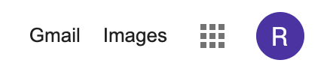

This should take you here:

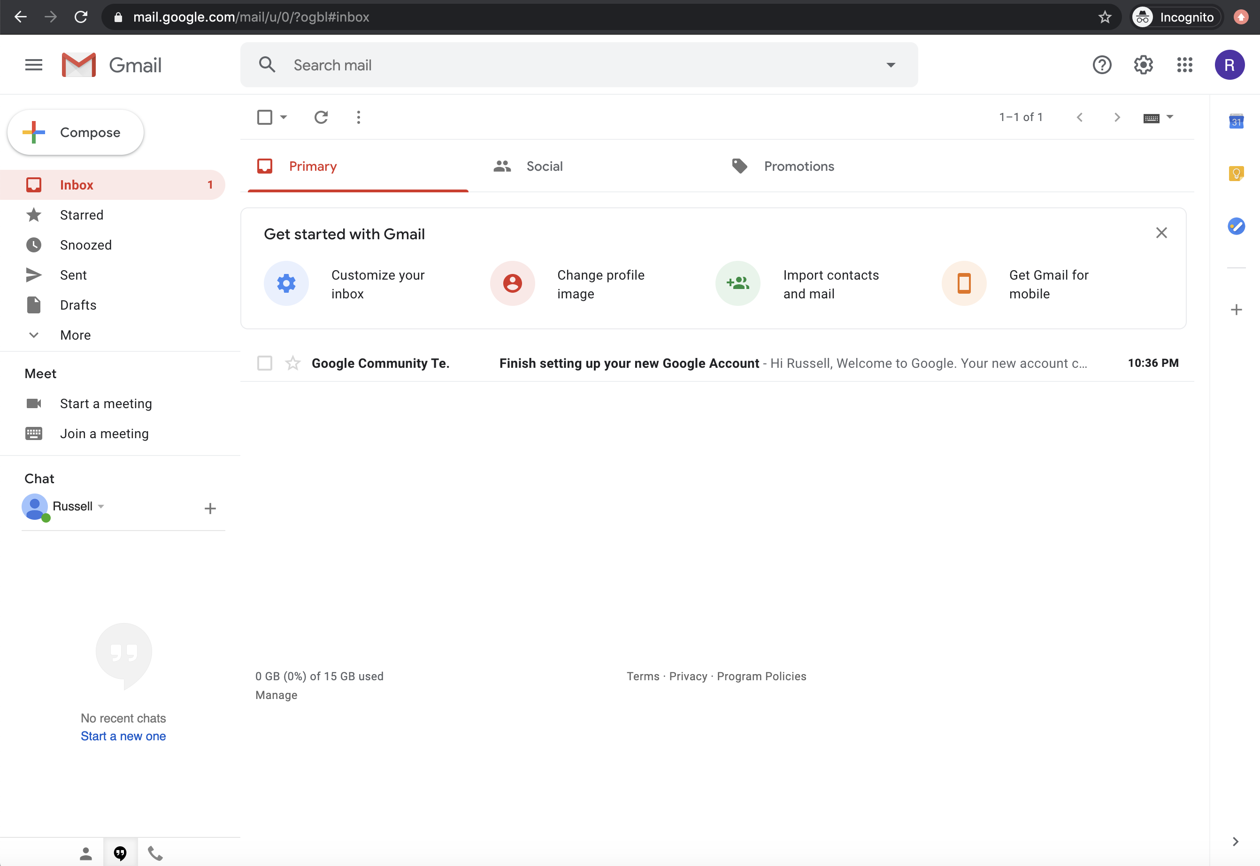

Click on “Compose” in the top left to send an email and use the template shown above:

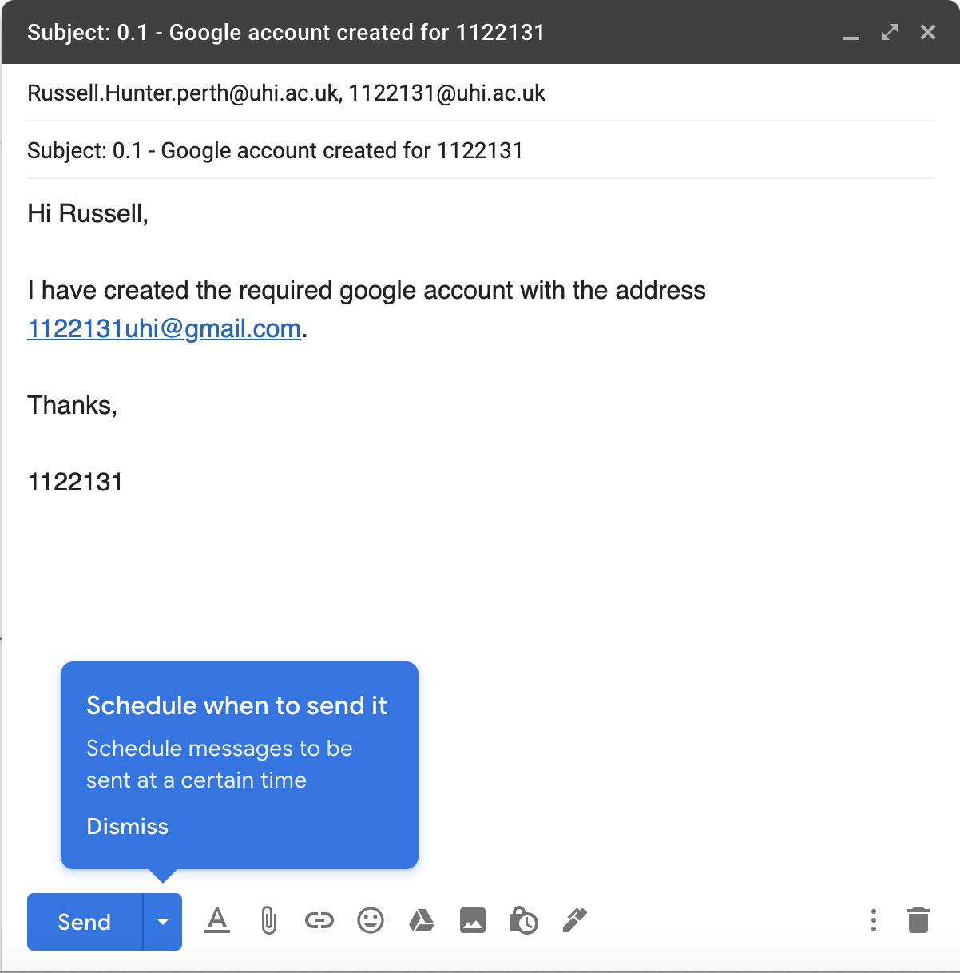

Click on Send and you are good to go. Well done.

* 1. Working with BigQuery

You should be logged in to your new Google account. If you will remember from above, the associated email address is given by the pattern <student number>[uhi@gmail.com](mailto:uhi@gmail.com). When logged in you should see something like this in the top right corner:



The circular “R” is my account image, probably as my name is Russell.

We are now going to set up BigQuery. At the moment, it doesn’t matter what BigQuery is as we will get into that later but just for context:

“BigQuery is a fully-managed, serverless data warehouse that enables scalable analysis over petabytes of data. It is a serverless Software as a Service that supports querying using ANSI SQL. It also has built-in machine learning capabilities”

However, if I can simplify this definition from Google for our purposes, it is a database that we will use SQL in order to manage our big data that we are required to use in this course.

Don’t worry!!! SQL examples will be given to you.

Firstly, go to this web page (remember you should be logged in to your new account): <https://cloud.google.com/bigquery/docs/bigquery-web-ui>

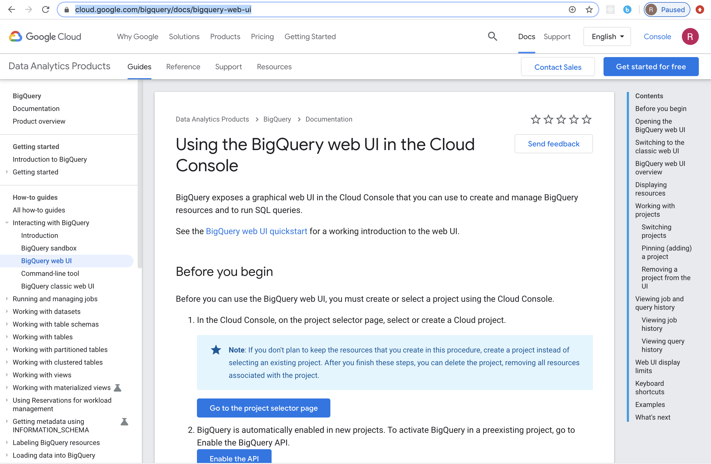

This is a really nice to follow tutorial that we can use to get started.

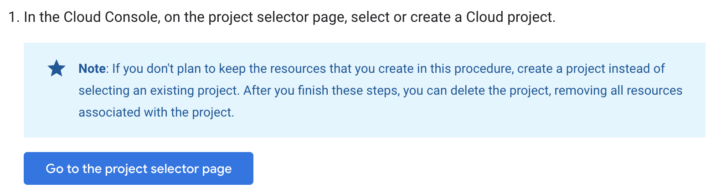

Click on the button “Go to the project selector page”:

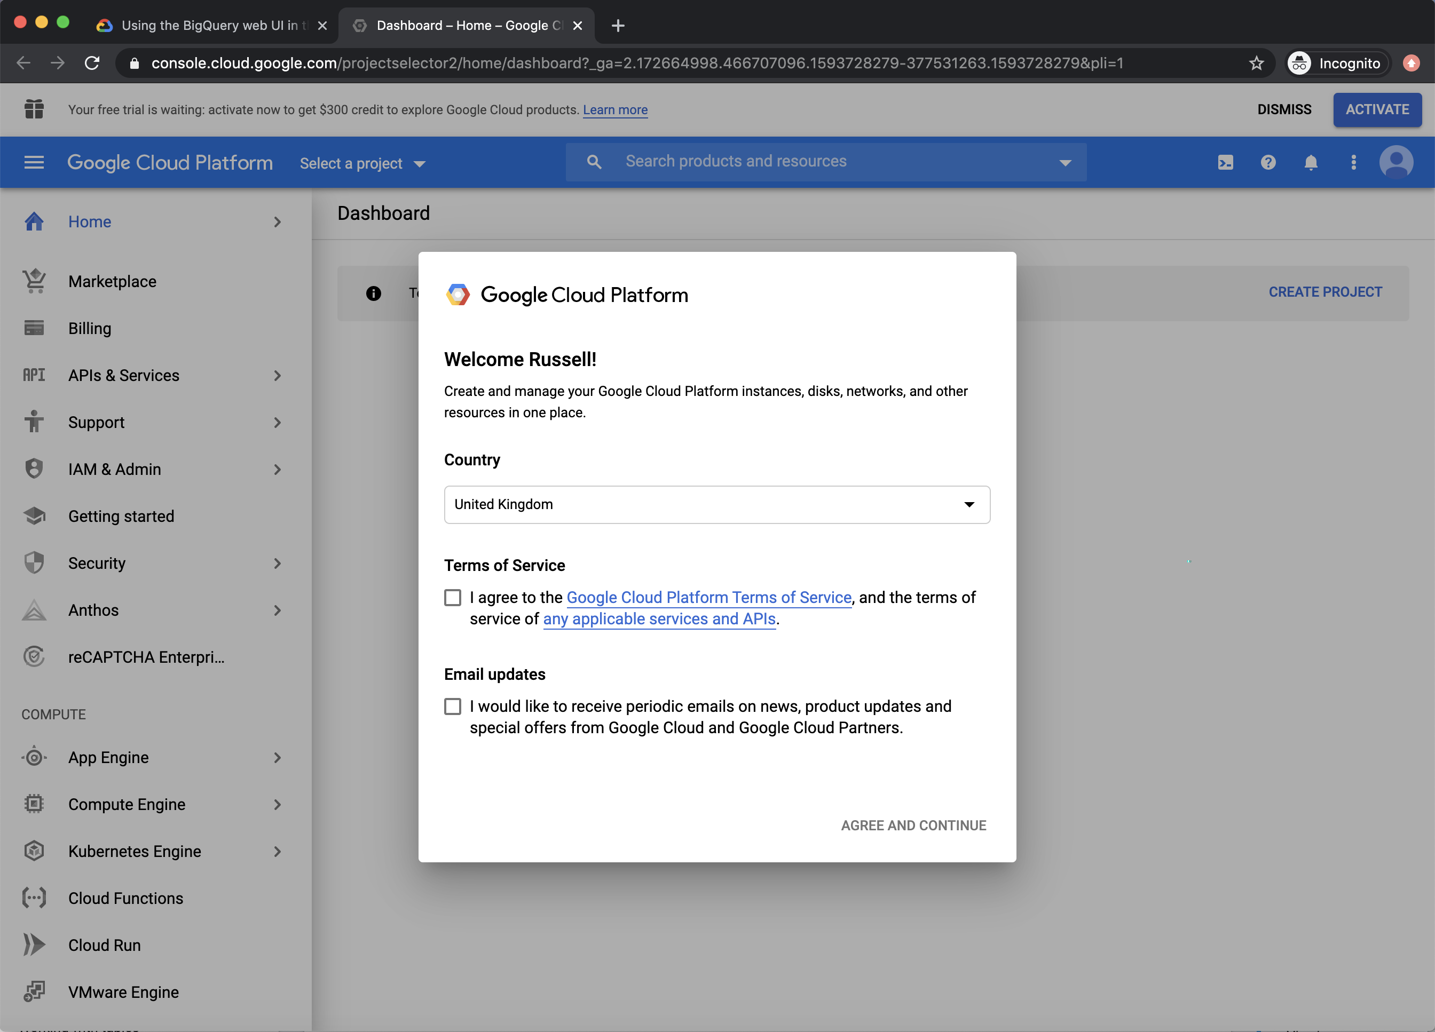

Agree to both the Terms of Service and Email updates:

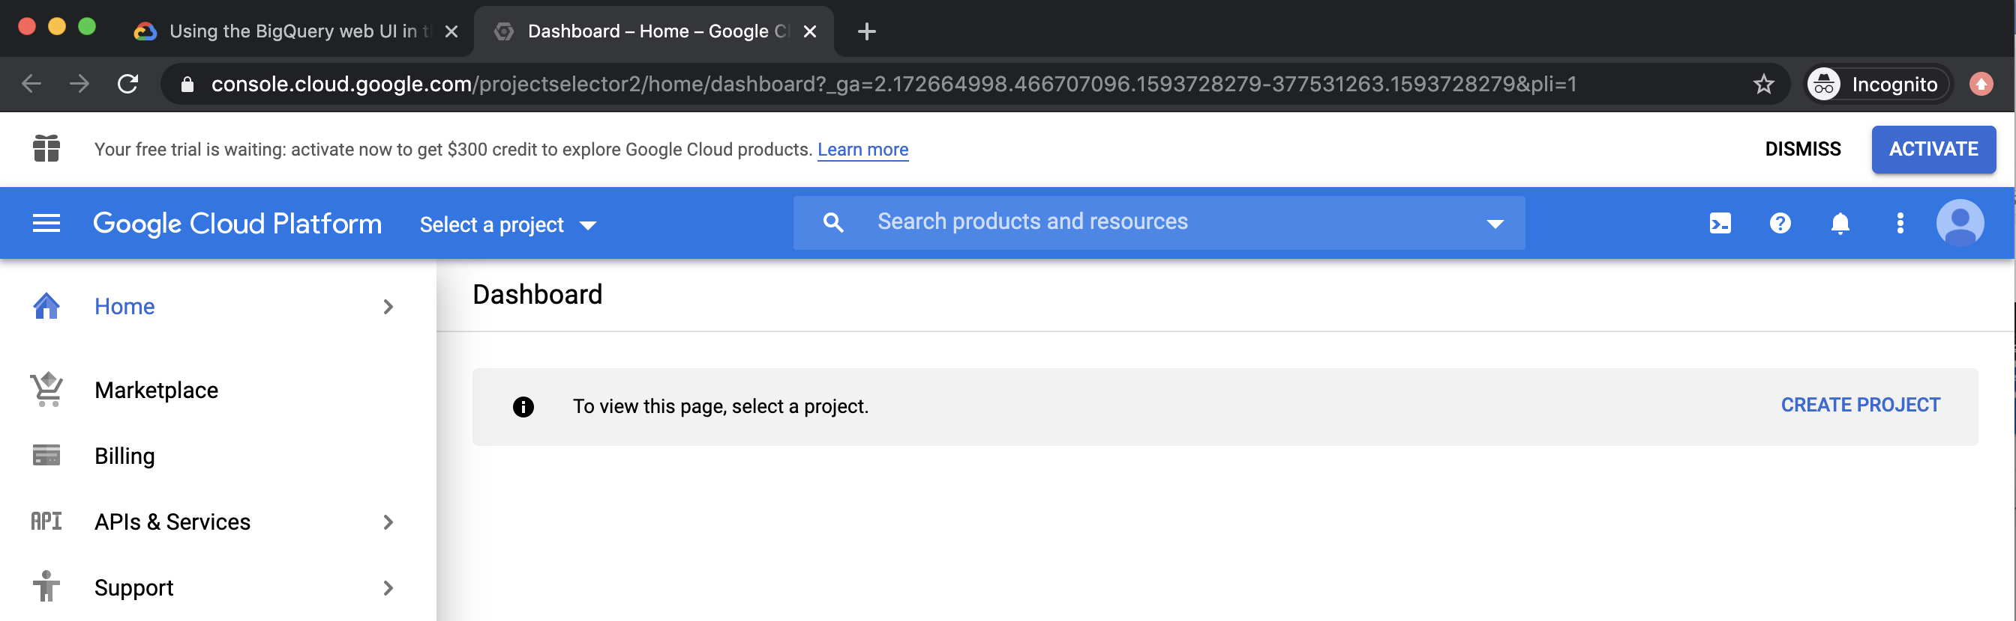

Click on “Create Project” on the right-hand side:

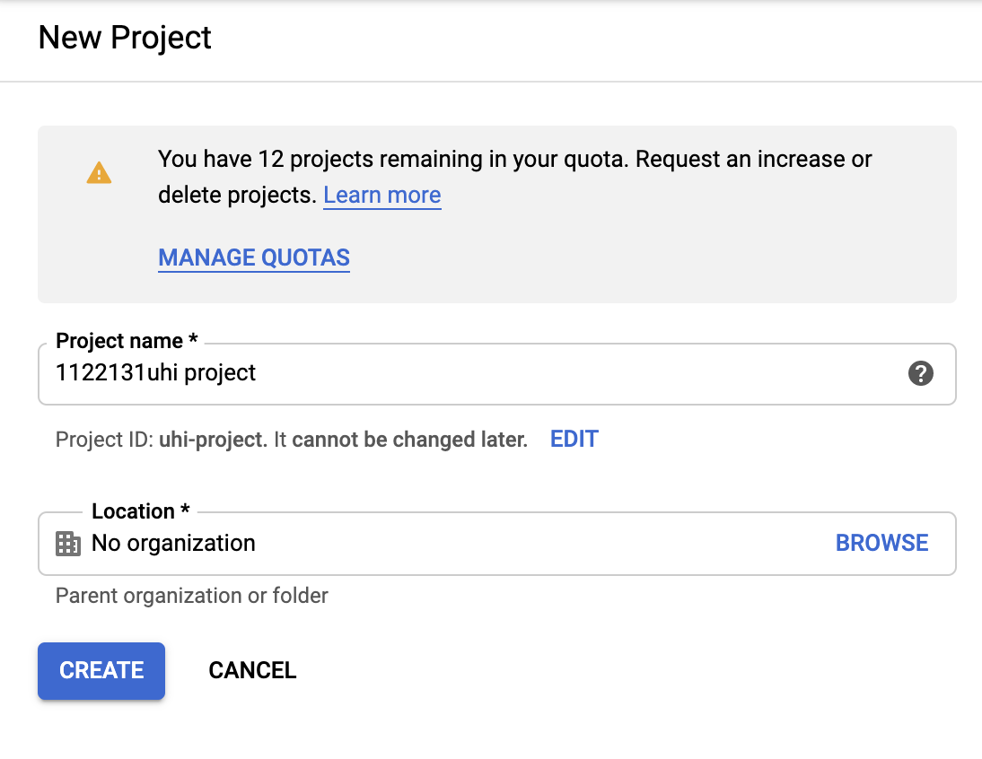

It doesn’t really matter what your Project name is, but I used:

“<student number>uhi project”

Click on “Create”. After a short amount of time you will get a Dashboard like this:

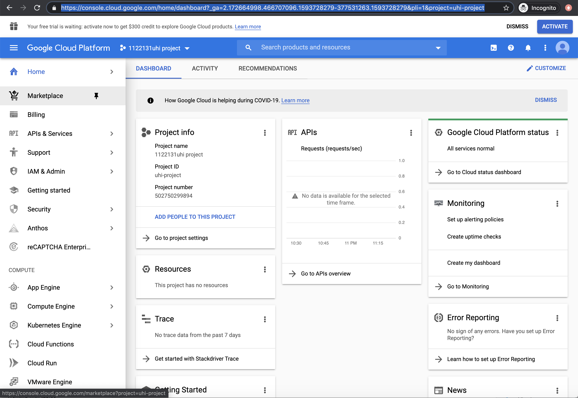

*For future reference, to get back to BigQuery, open this link: <https://console.cloud.google.com/bigquery>

On the dashboard page, where we are just now, scroll down the vertical menu bar on the left-hand side until you get here and click on “BigQuery”:

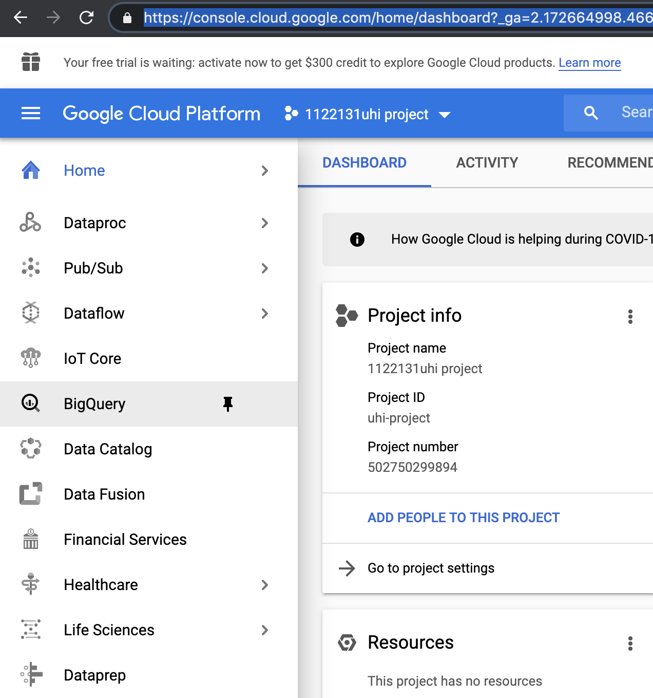

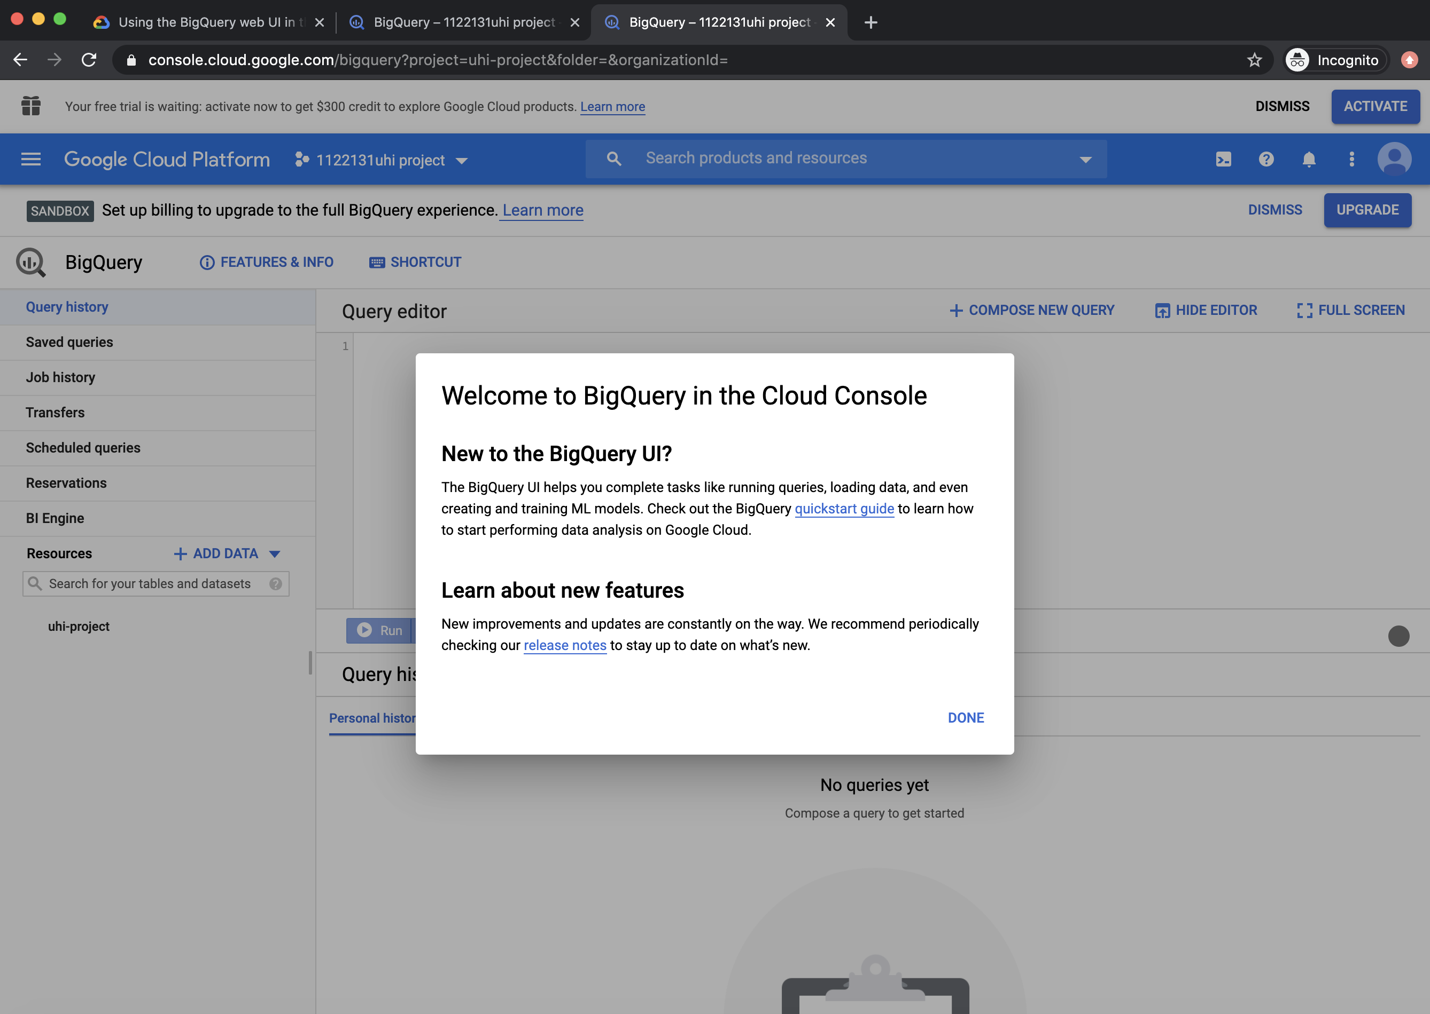

Click on “Done”:

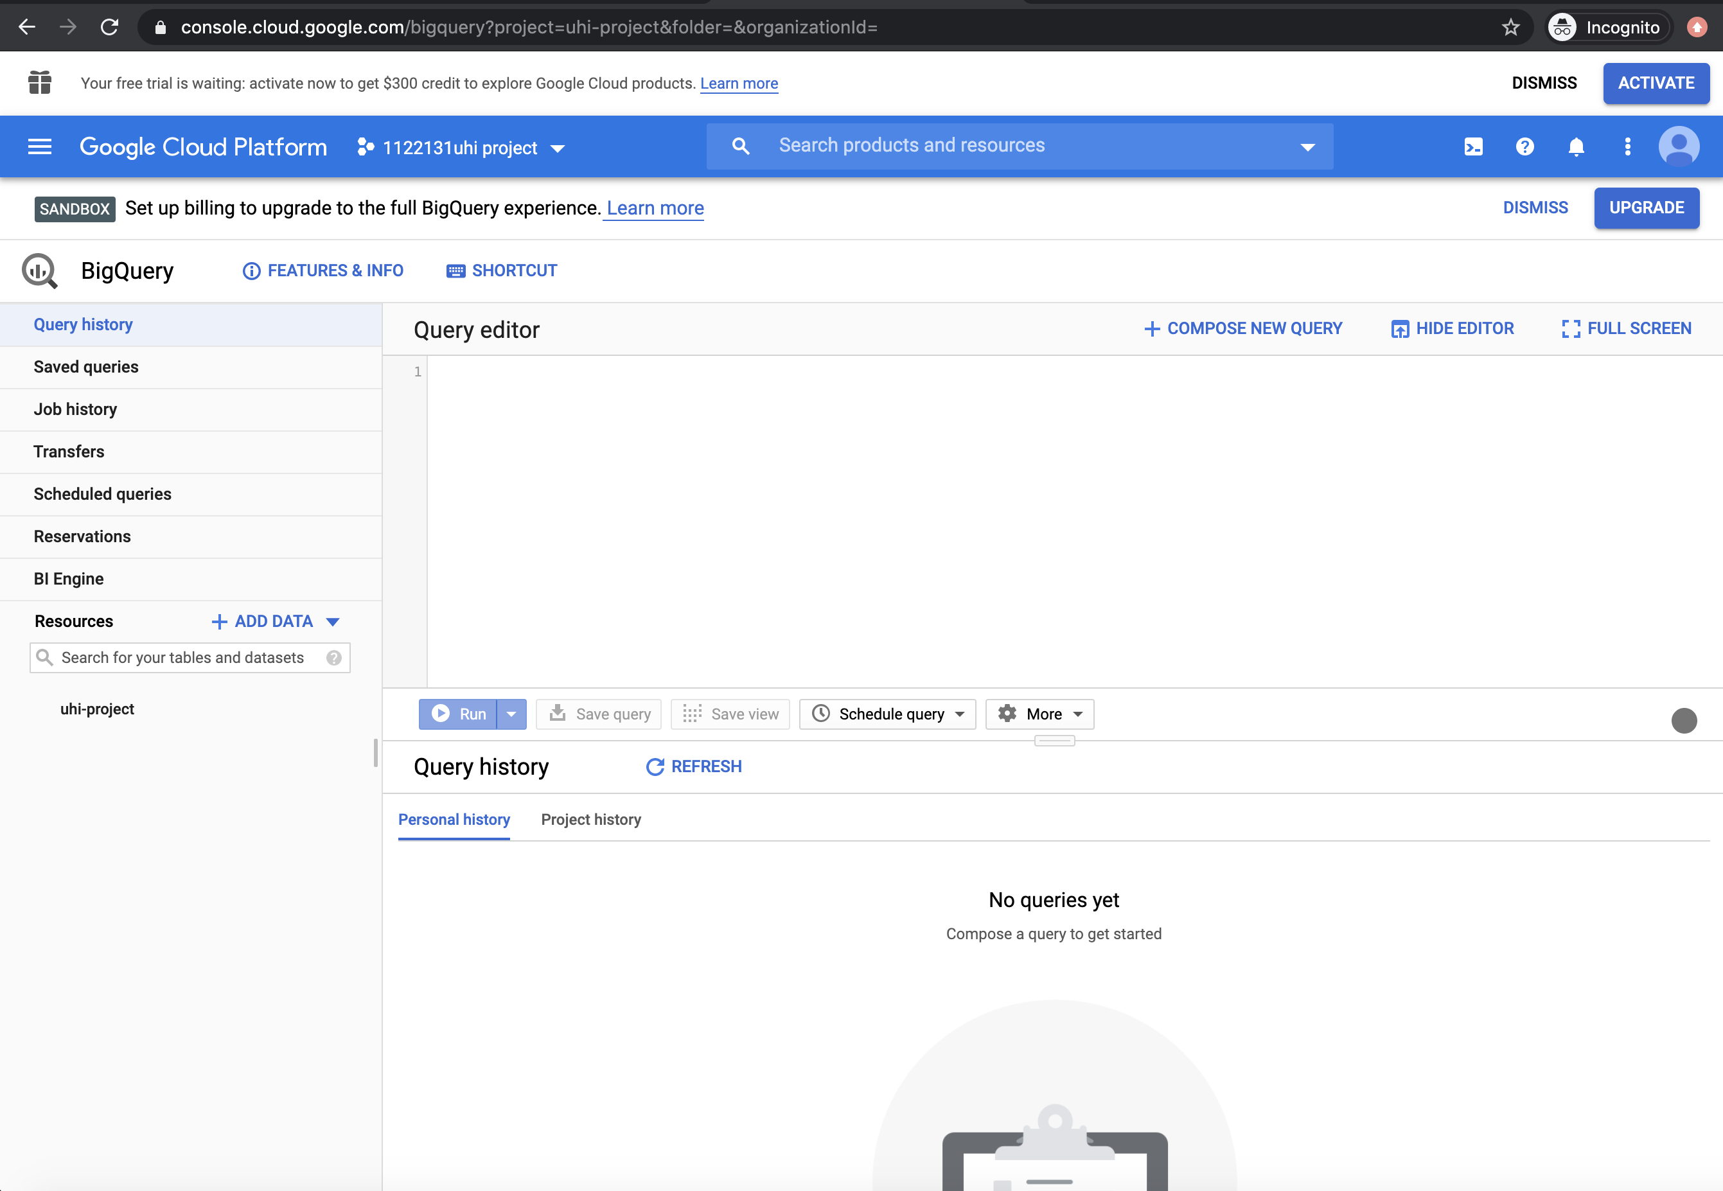

Fantastic, you are all set up with BigQuery. Don’t worry about anything in here. You should also be careful as you have a monthly quota of free usage:

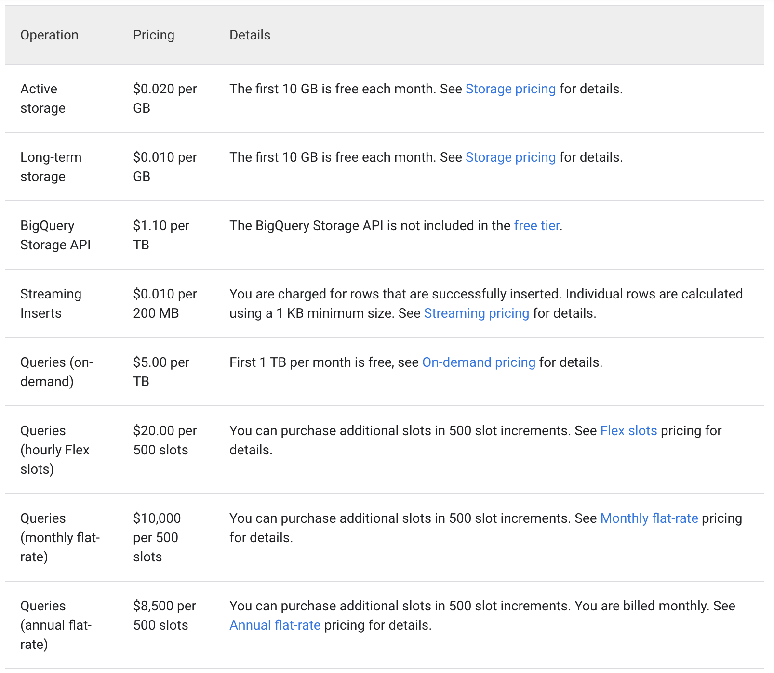

As you can see, with queries you get the First TB per month free. So, we will be ok. For now, close down BigQuery and we will come back to it soon.

0.3 Working with Google Colab

What is Google Colab?

“Colaboratory, or ‘Colab’ for short, is a product from Google Research. Colab allows anybody to write and execute arbitrary python code through the browser, and is especially well suited to machine learning, data analysis and education. More technically, Colab is a hosted Jupyter notebook service that requires no setup to use, while providing free access to computing resources including GPUs.”

This one is fairly easy to get set up and is completely free ☺.

Firstly, go to this link: <https://research.google.com/colaboratory>. Remember, you should be logged in to your new Google account that uses your UHI student number:

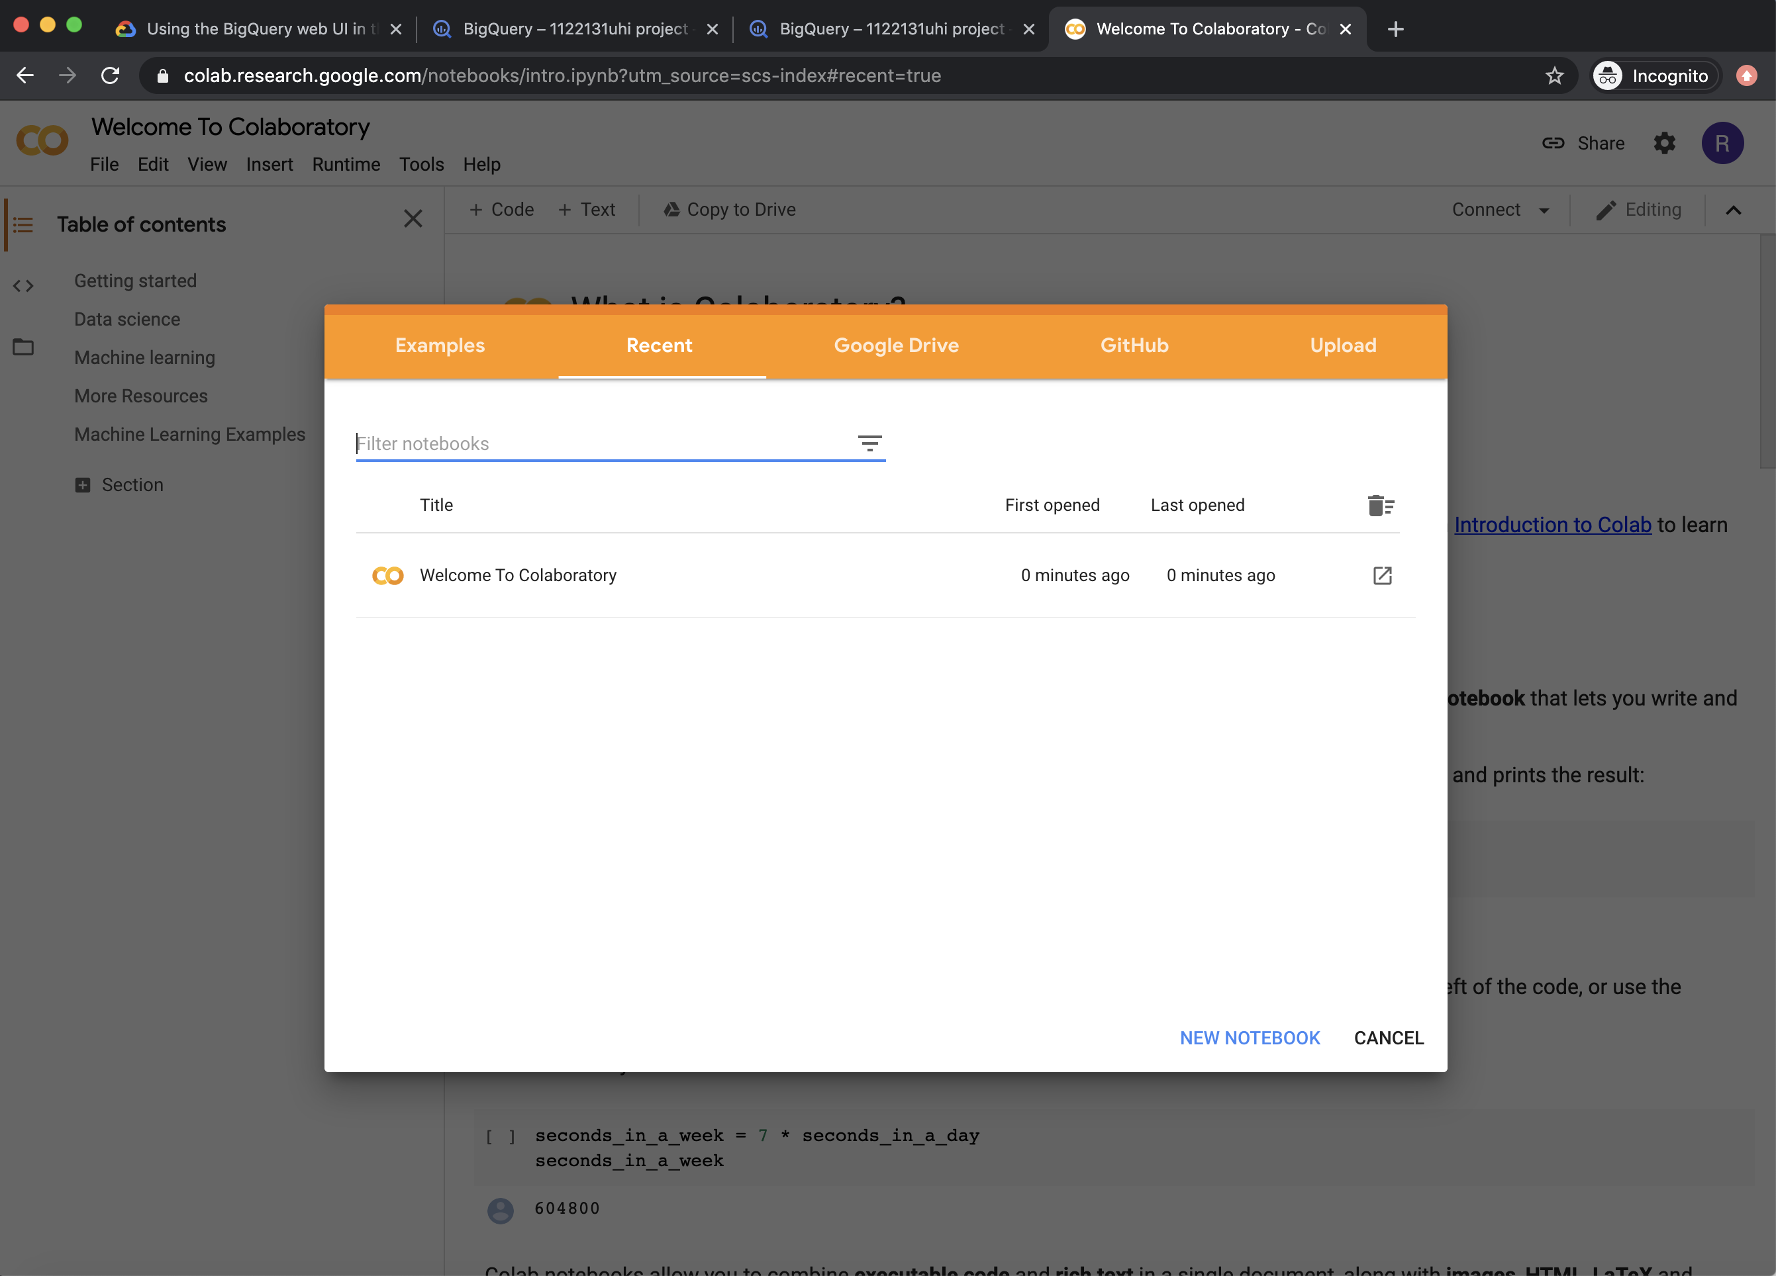

Just for fun, let’s create our first notebook. Click on “NEW NOTEBOOK” in the bottom right-hand corner of the modal window:

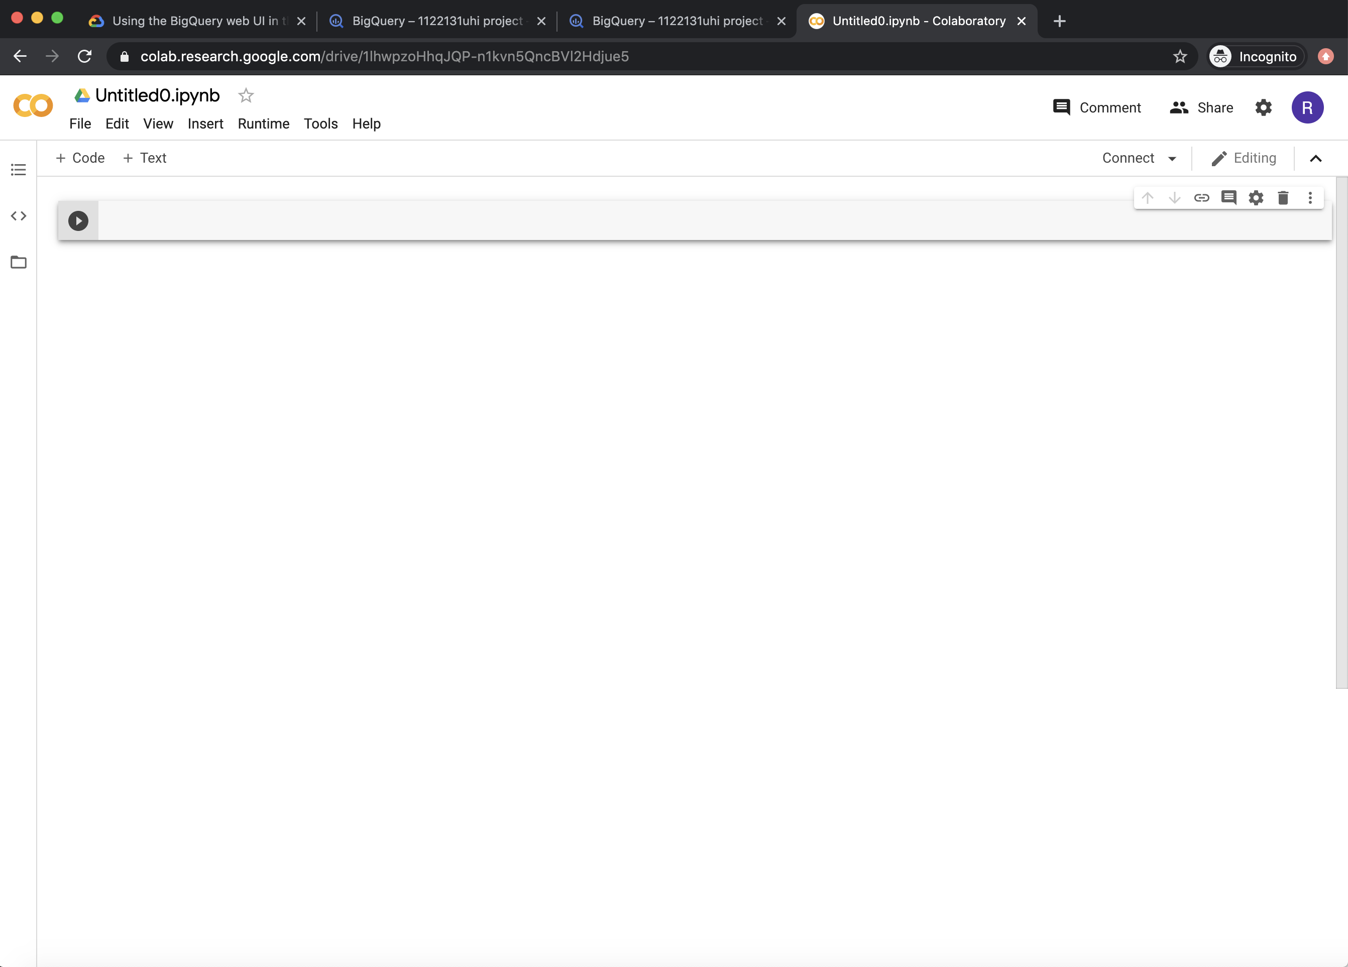

First thing we can do is rename this. In the top left-hand corner it should say something like “Untitled0.ipynb”. Click on this and change it to “myfirstnotebook.ipynb”.

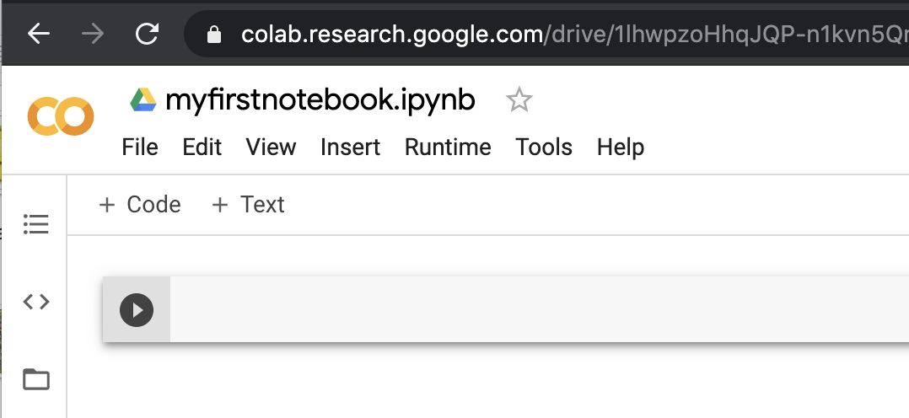

Inside the code box, type in the following:

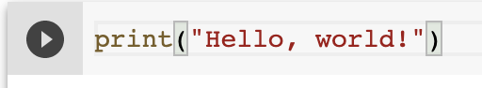

Then click the little play button, you should get a spinning circle around it. This means the code is running. We have basically made a print statement using python:

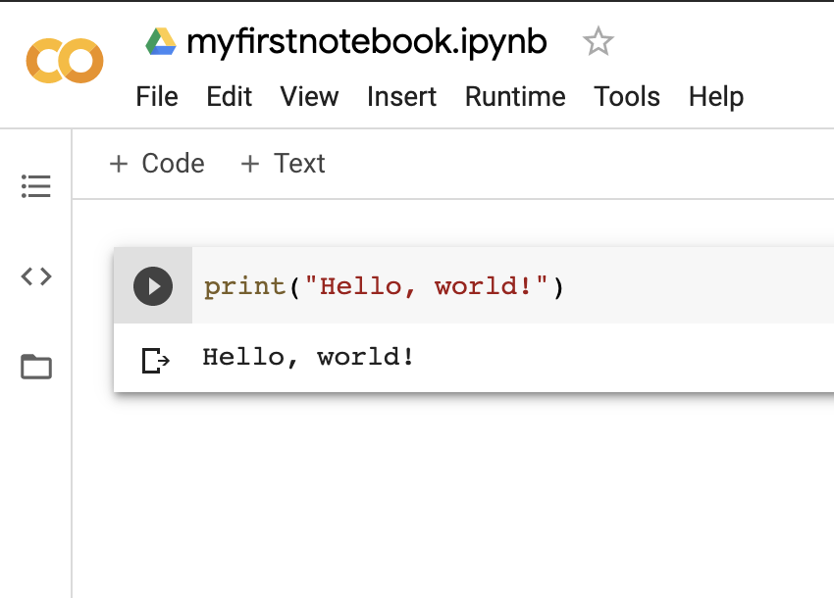

Also, you can see if the sheet has saved where it says “All changes saved”:

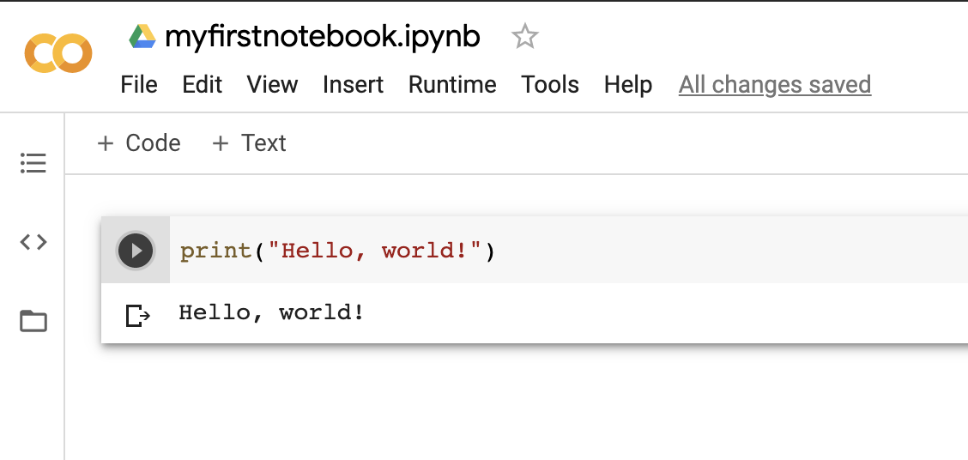

If you close it down, and want to access it easily from the logged in Google homepage, use the 3 x 3 grid icon to open Google Drive:

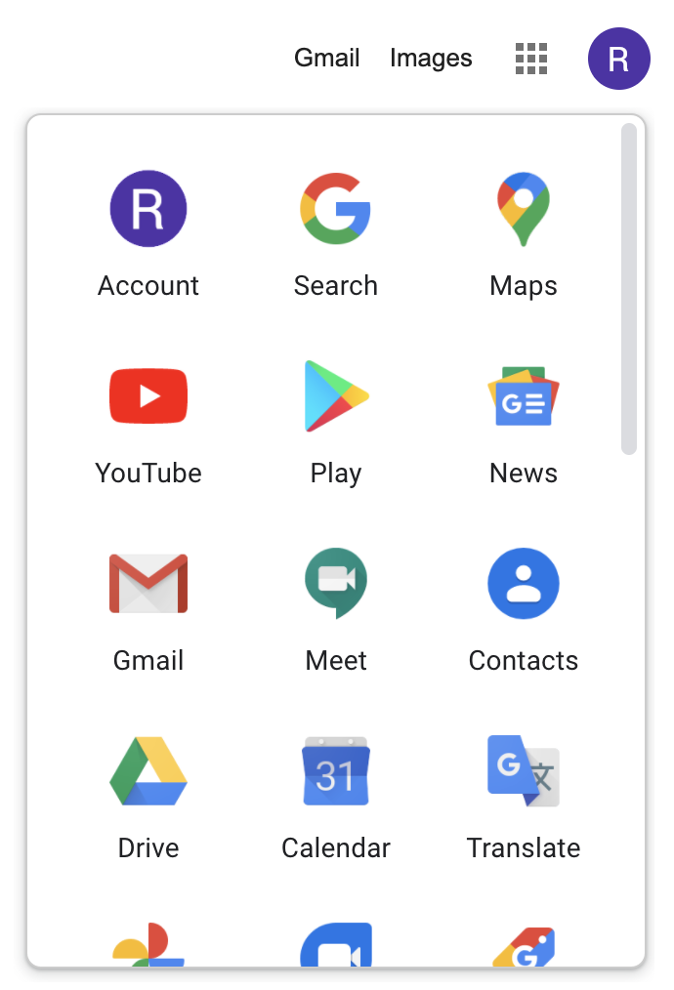

Click on this icon:

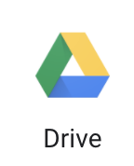

You can now see it in your Google Drive:

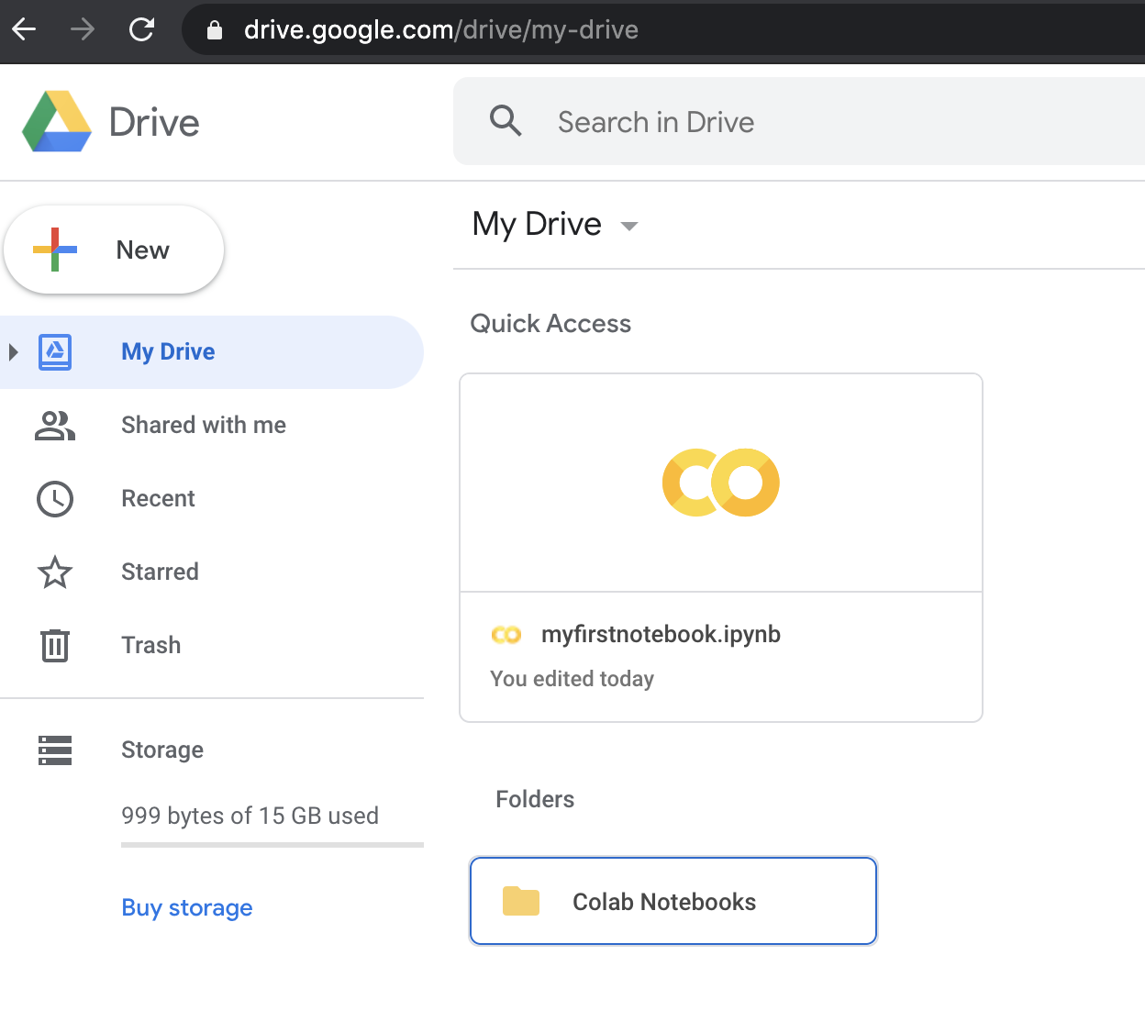

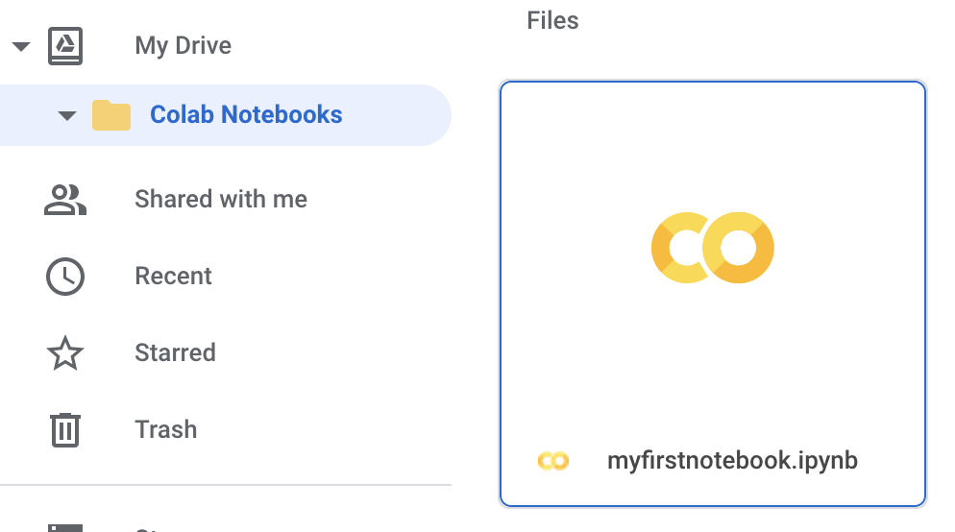

You can double-click on the file:



And you will see the following:

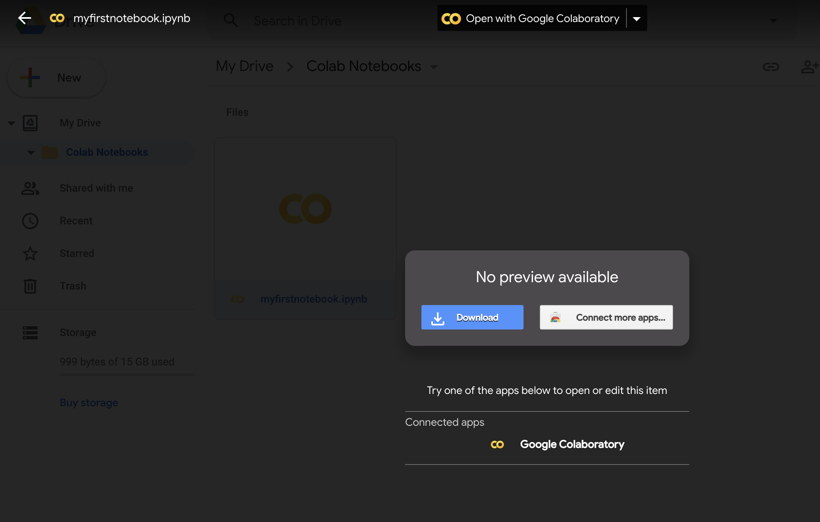

Where you can either download or open the notebook in Google Colaboratory. Let’s open it in Google Colaboratory by clicking on this link at the top of the web page:



And hey presto, the notebook opens:

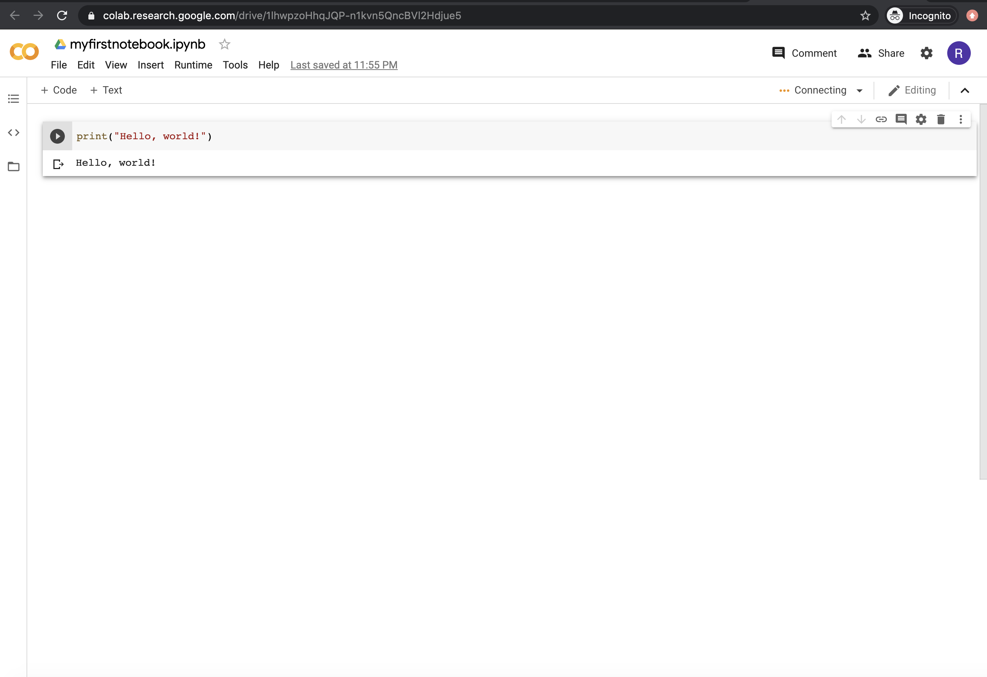

We can also create new notebooks using the File menu:

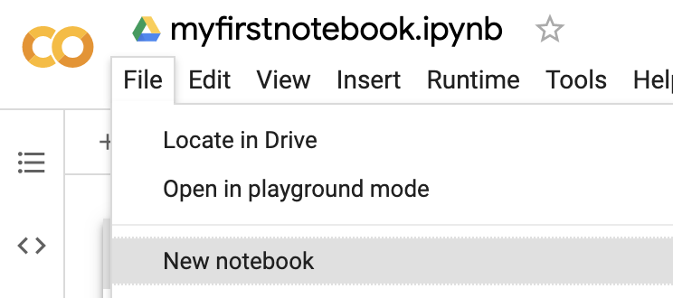

The last thing is pretty cool. If you need help, either from me or one of your peers, you can use the “Share” button in the top right:

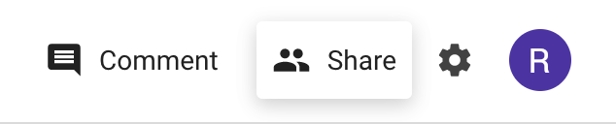

Then you simply add the persons email address:

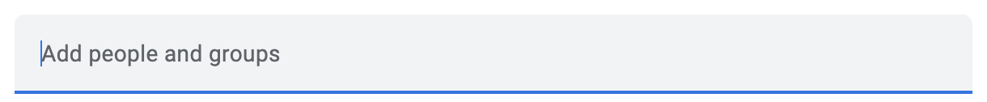

Then press send:



I or someone else can make changes. It doesn’t happen live, but I can make changes that you will see as soon as they are saved or Run. This was made by me from another account:

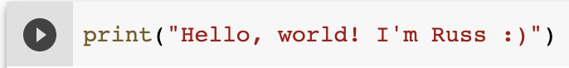

I was able to access it via a link in an email or in my own Google Drive. Very handy for ensuring progress.

This is enough for now. Feel free to mess around in here and play with some things in this tutorial (please note, you shouldn’t need to worry too much about learning everything in here as everything you need will be documented in the course):

<https://www.tutorialspoint.com/google_colab/index.htm>

0.X GitHub

We are going to use GitHub to host the data files that you will create throughout this module. Students have access to a full membership with git. If you already have an account that allows you to create private repositories, then you can ignore the setting up procedure and use this instead. However, it would be best to use your UHI email addresses as you get access to lots of cool free stuff. See here <https://education.github.com/pack>.

In this module, we will only be using GitHub at a very simple level. In fact, we will only be uploading or saving files to it without the need to use desktop tools, IDE’s or terminals (command lines).

Let’s sign up:

1. Open up Chrome and go to <https://github.com/>

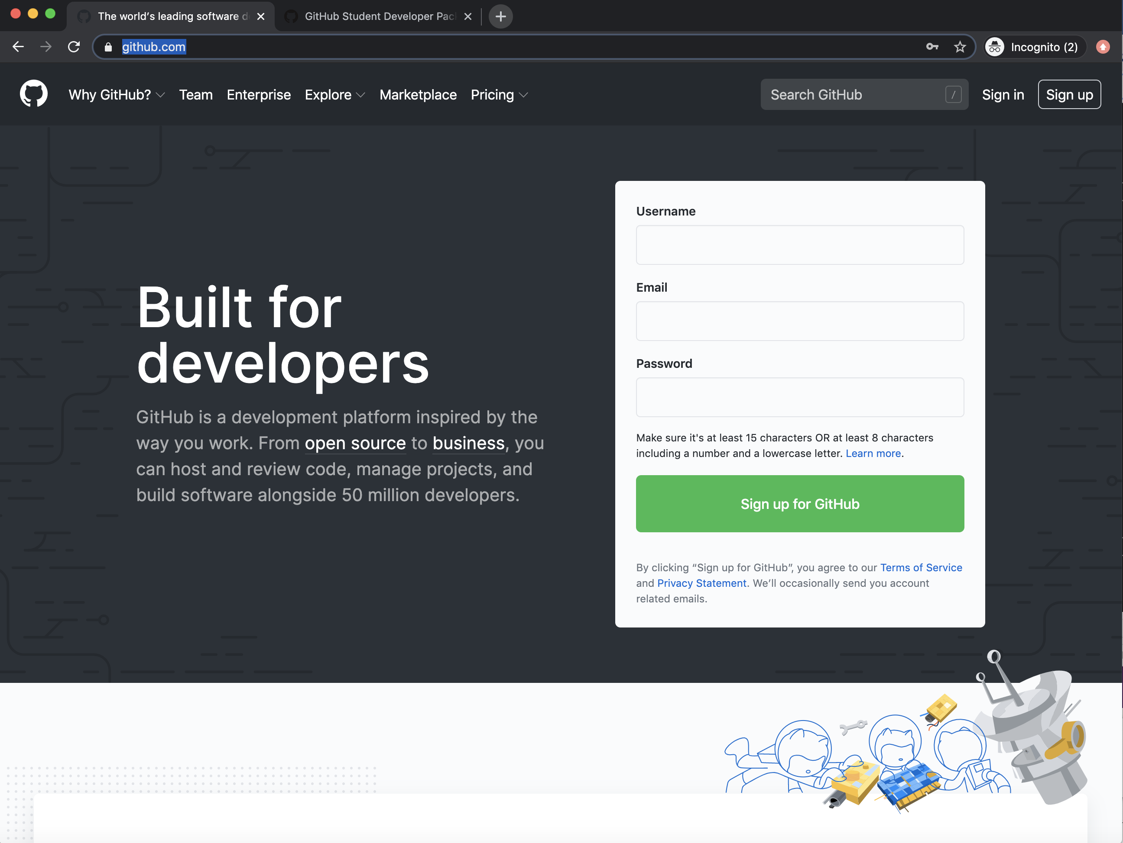

1. Now, click on Sign Up

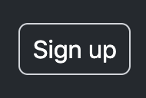

You should see the following:

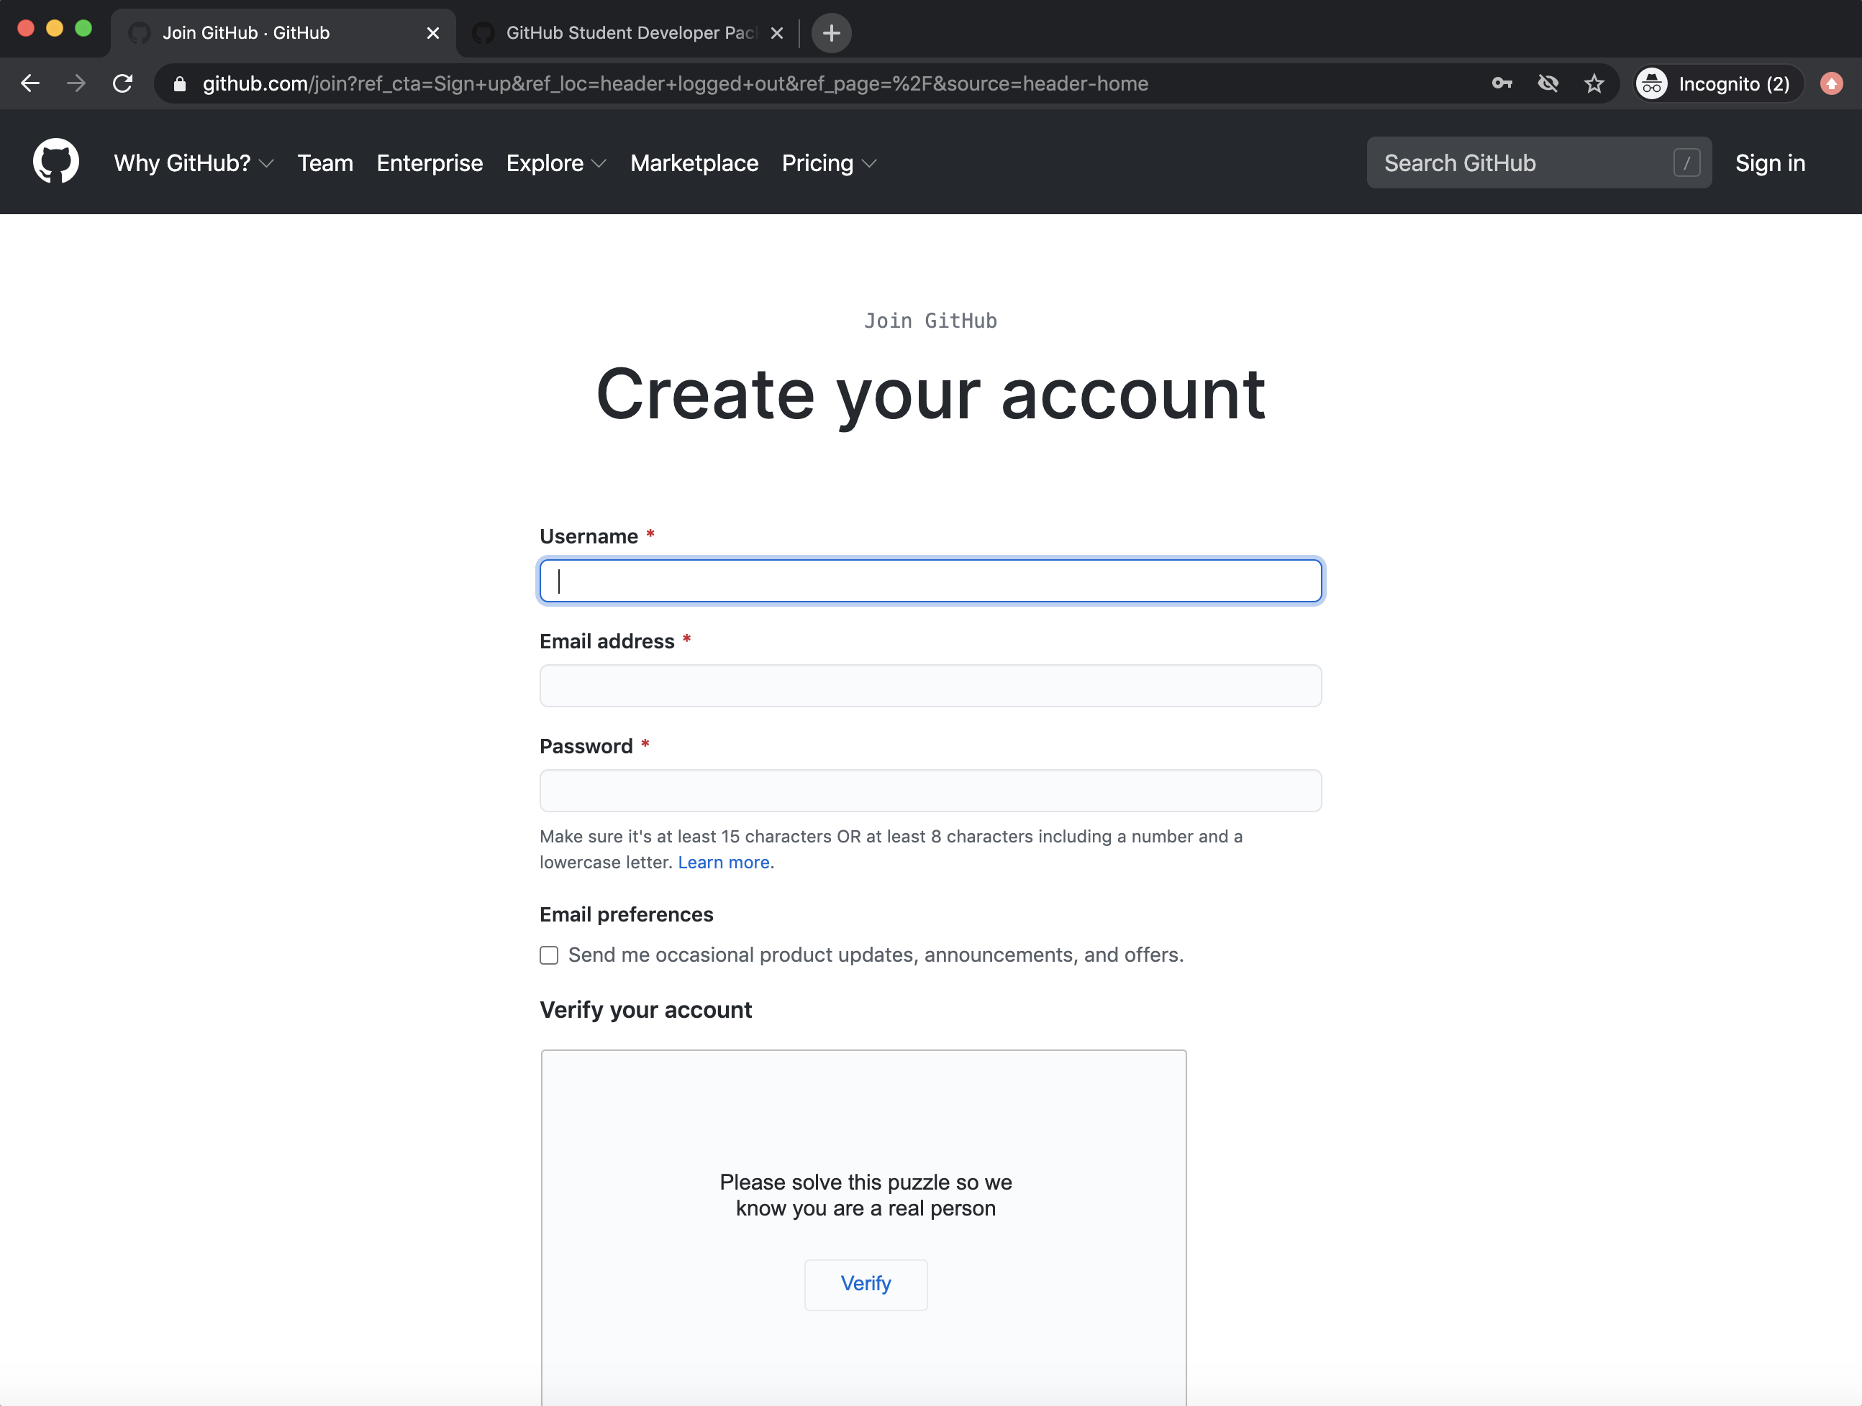

I would use your <student number>uhi as your Username. For example, for my made-up student account my Username would be 1122131uhi. Then I would use your actual UHI email address, again, my made-up student email address would be [1122131@uhi.ac.uk](mailto:1122131@uhi.ac.uk).

Make a memorable password.

Then verify the account by clicking on Verify and doing the puzzle.

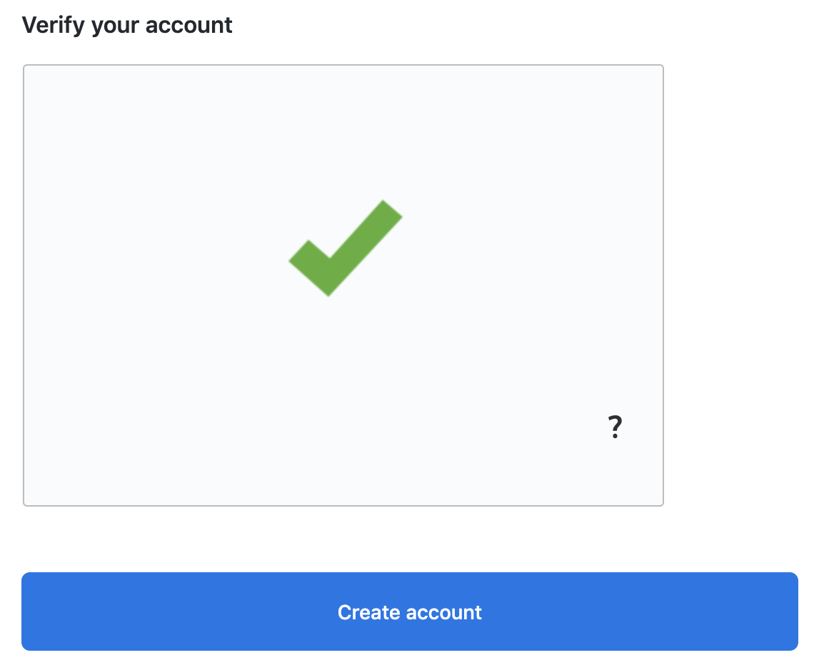

Lastly, click “Create account”.

1. Fill out the next page, which should look like this:

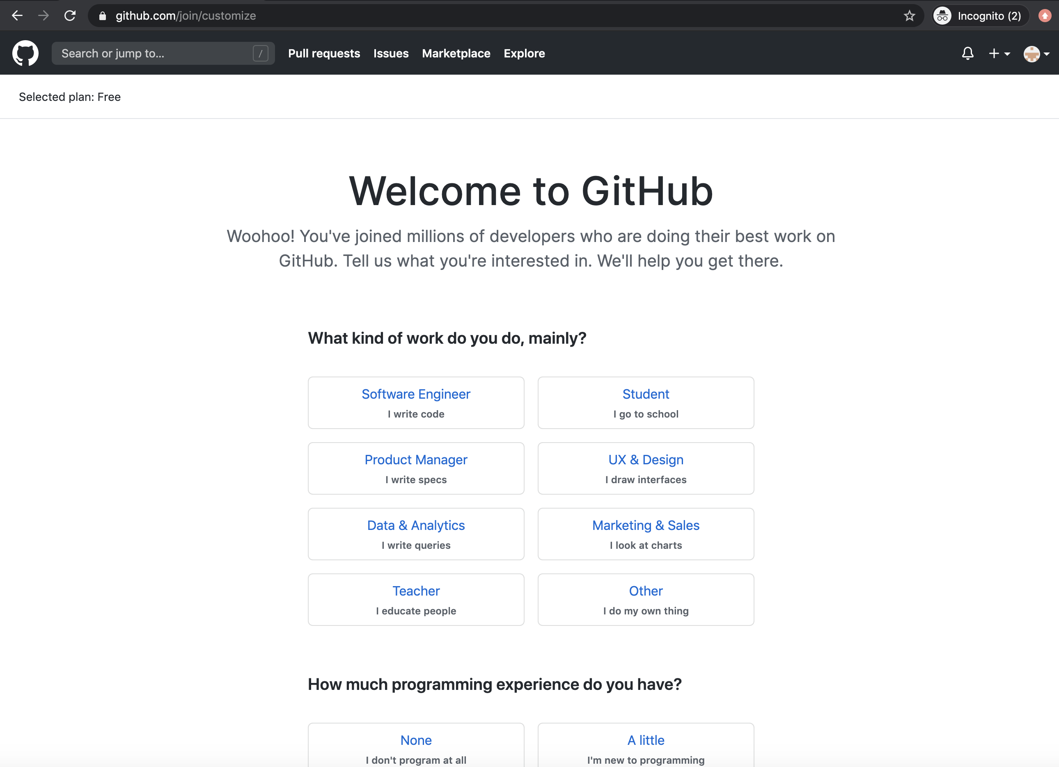

Then click on “Complete setup”:



1. Verify your account:

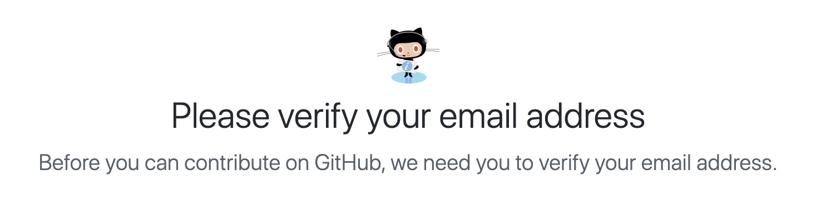

You will need to open up your email account at UHI (if you used this). In the email there will be a button “Verify email address”.

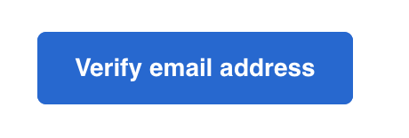

Click on this.

1. Now, we will create a repository.

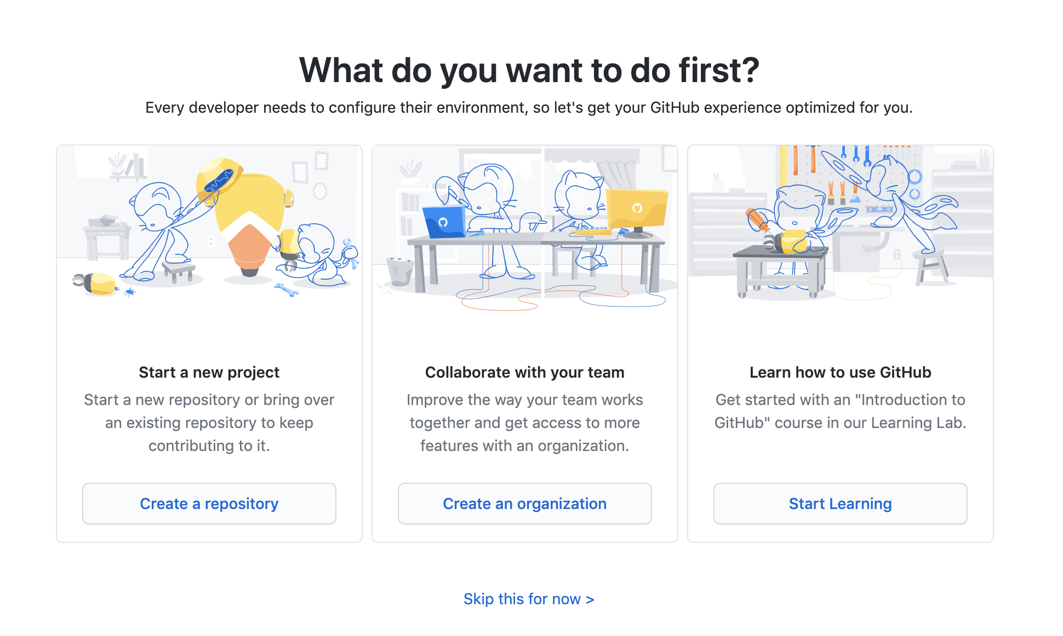

Click on “Create a repository”:

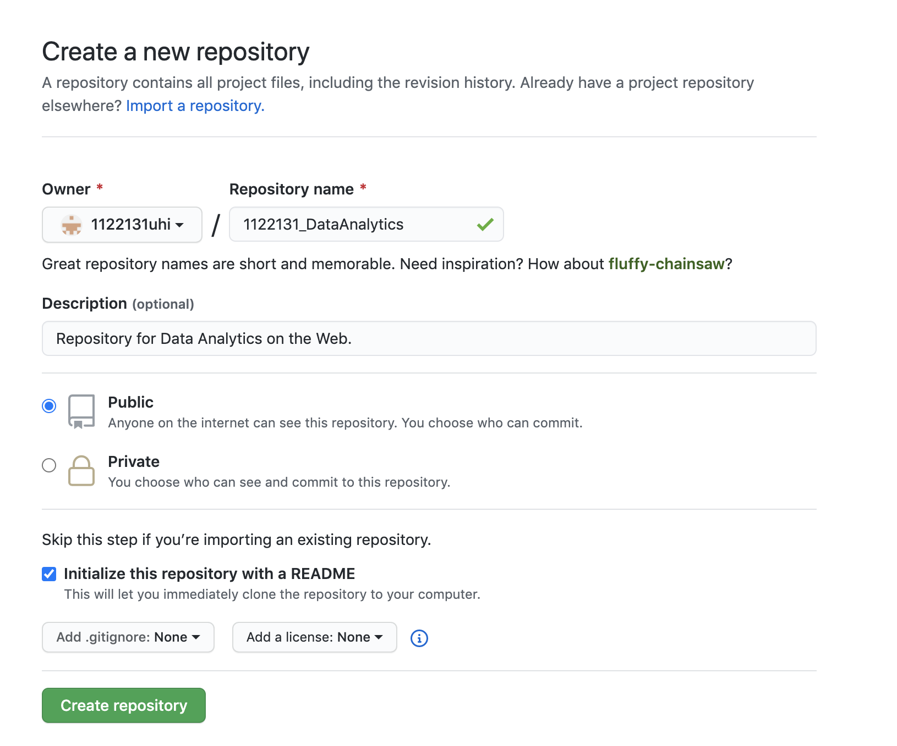

Add a Repository name (I went for 1122131_DataAnalytics, so why not follow the pattern i.e. <student number>_DataAnalytics), add a description, I made it fairly simple. Just make a Public repo (check the radio button). Also, click the checkbox “Initialize this repository with a README” then click “Create repository”:

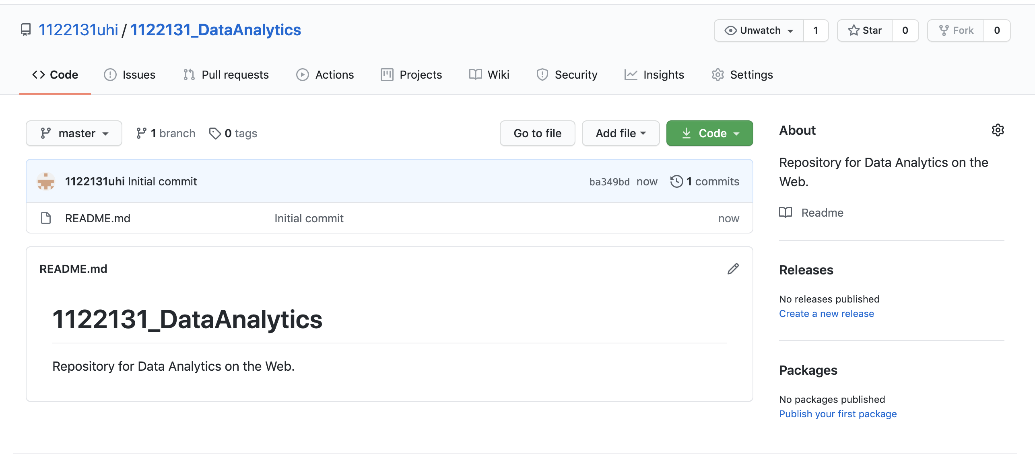

This is where you will save all of your Google Colab sheets and csv data files.